**Fatima Jinnah Women University**

***Department of Software Engineering***

|  |
| --- |
|  |
|  |  |

**SUBJECT: CC LAB**

**SUBMITTED TO: SIR SHOAIB**

**SUBMITTED BY: ZUNAIRA NOOR**

**REGISTRATION NO: 2023-BSE-075**

**SEMESTER: V-B**

**Task 0 – Lab Setup (Codespace & GH CLI)**

**Create/open Codespace on your GitHub account (from any repo or a temporary starter repo).**

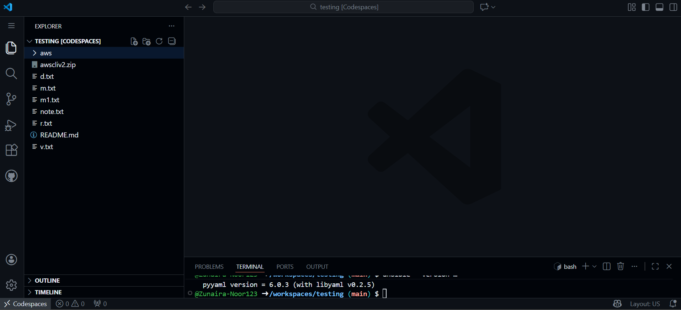

**Inside the Codespace terminal, configure GH CLI (if needed) and verify:**

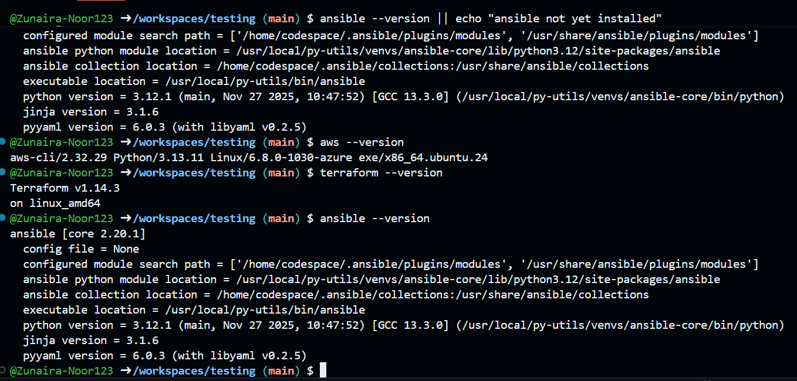

1. Ensure AWS CLI is configured with credentials that have permissions to create EC2, VPC, subnets, and security groups in region **me-central-1**:

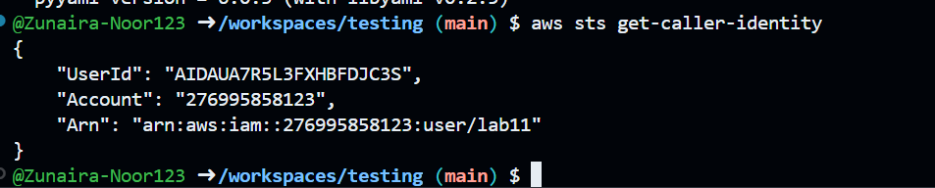

**Task 1 – Clone Terraform+Ansible repo & initial Terraform apply**

**Clone the repository (branch main)** inside the Codespace:

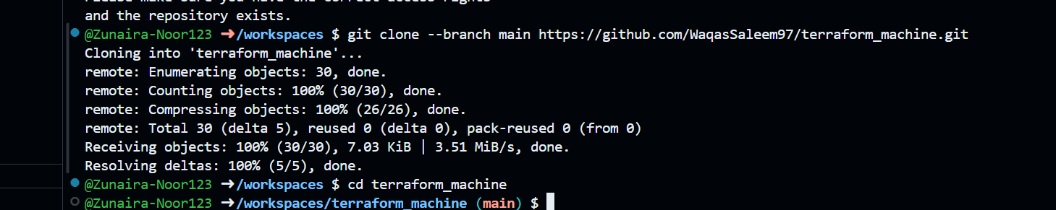

**Check SSH directory & generate SSH key pair** if not already present:



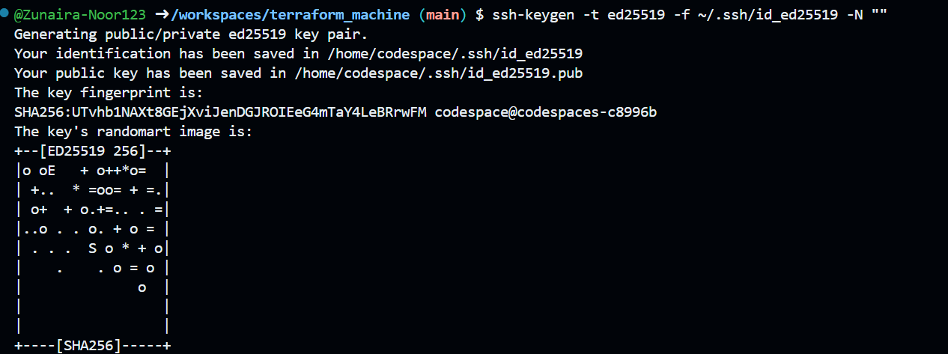

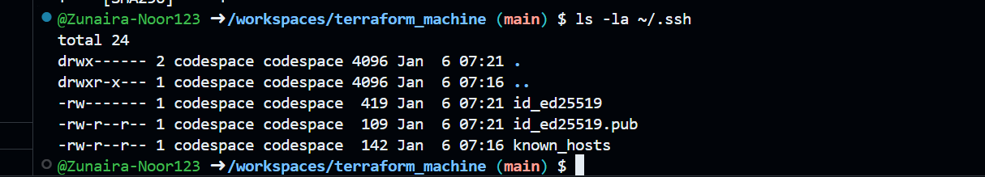

**Create terraform.tfvars** in the repo root:



Add the following content:

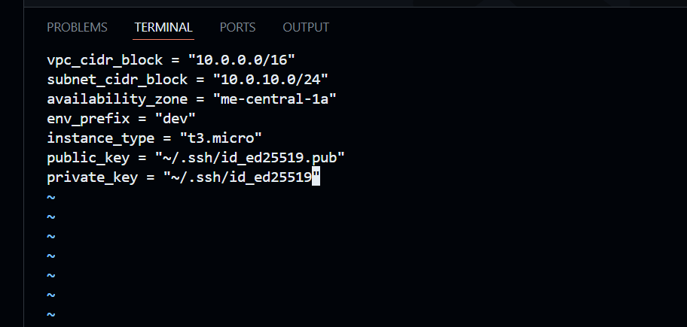

**Initialize Terraform**:

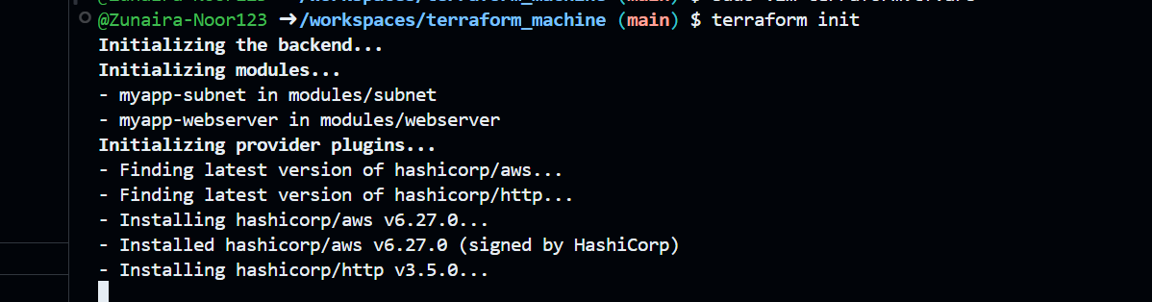

**Apply Terraform** to create **2 EC2 instances** (as defined in the existing Terraform code):

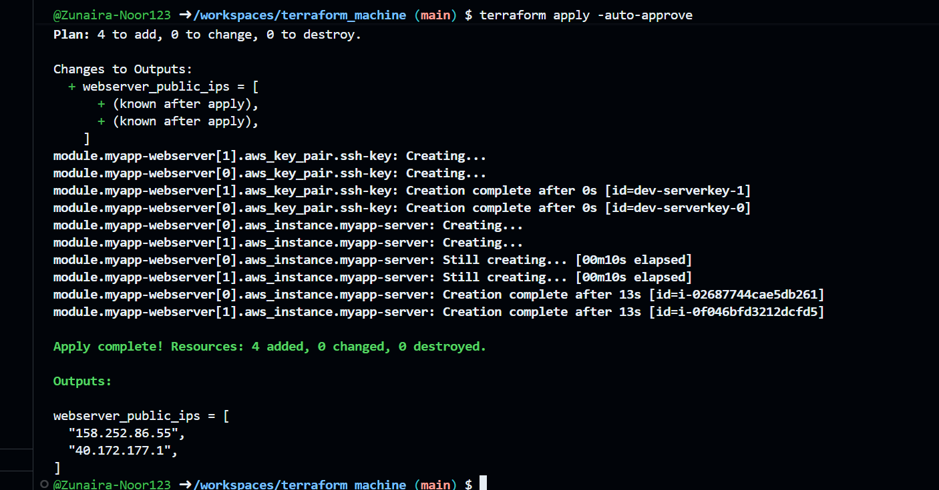

**Check outputs**:

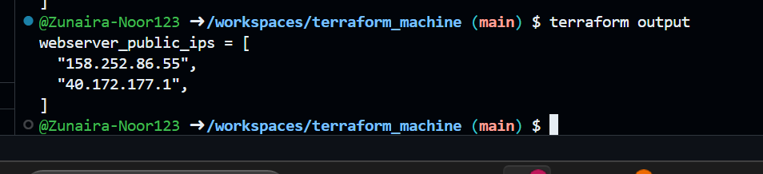

**Task 2 – Static Ansible inventory with two EC2 instances**

You will install Ansible (via pipx), create a static inventory, and verify connectivity.

**Install Ansible (core) using pipx**:

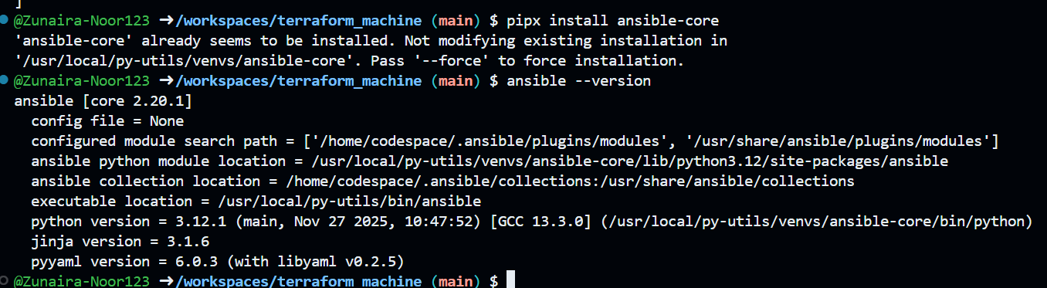

**Obtain the two public IPs** of your EC2 instances:



**Create Ansible inventory file hosts**:

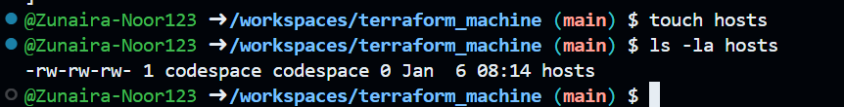

Add the following (**replace <public-ip-ec2> with your 2 real IPs**):

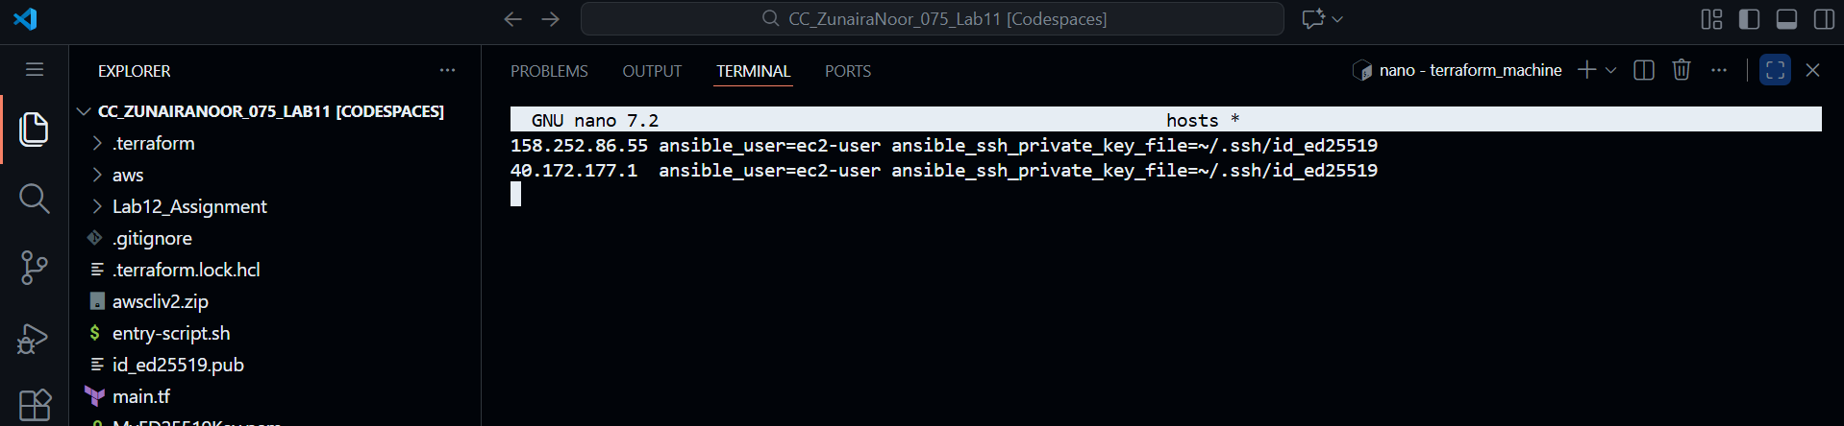

**Test connectivity**:

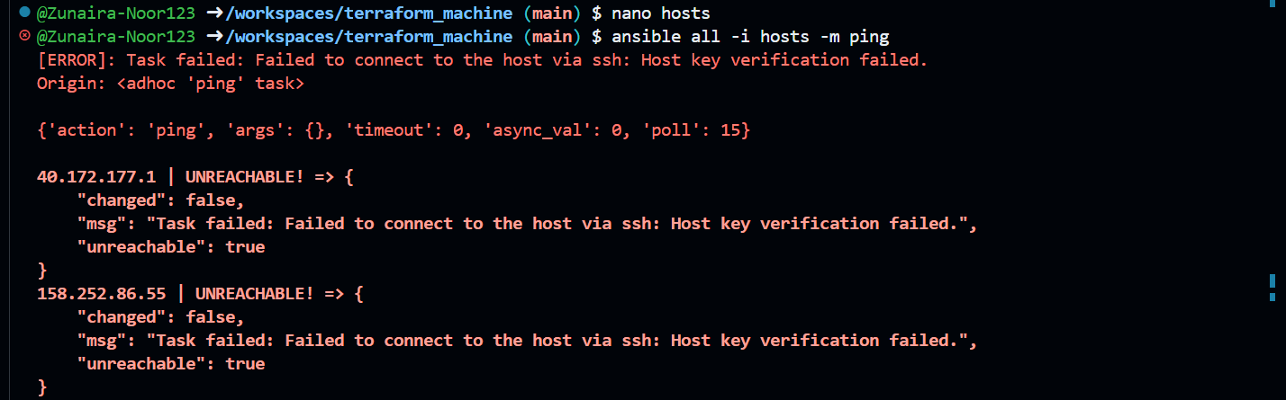

If it fails due to host key checking, **add** this to each line in hosts:

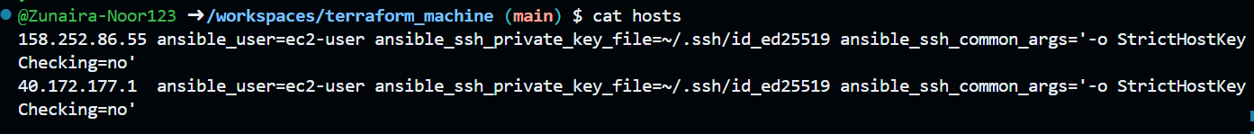

**Test connectivity**:

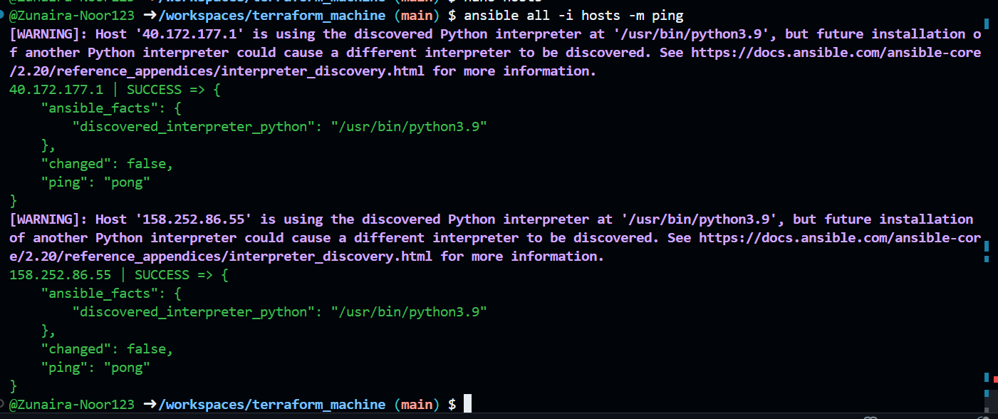

**Task 3 – Scale to three instances & group‑based inventory**

You will expand to 3 web servers via Terraform’s count and restructure your inventory into groups.

**Update your Terraform module for webservers** in main.tf to use count = 3:

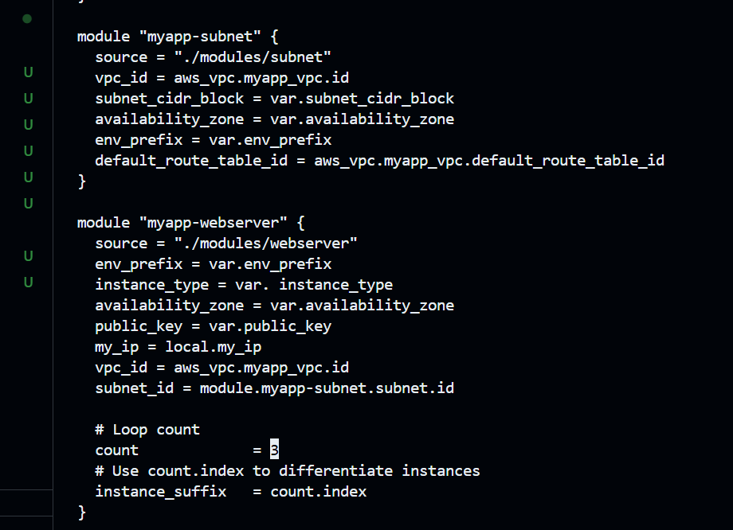

**Apply Terraform** to get 3 instances:

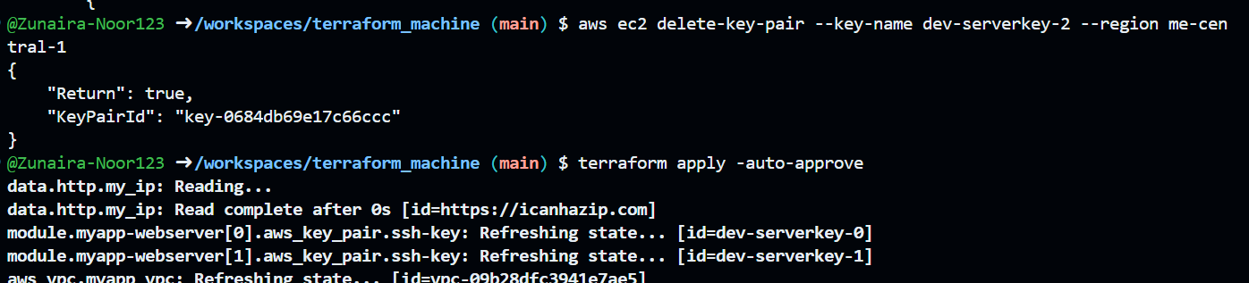

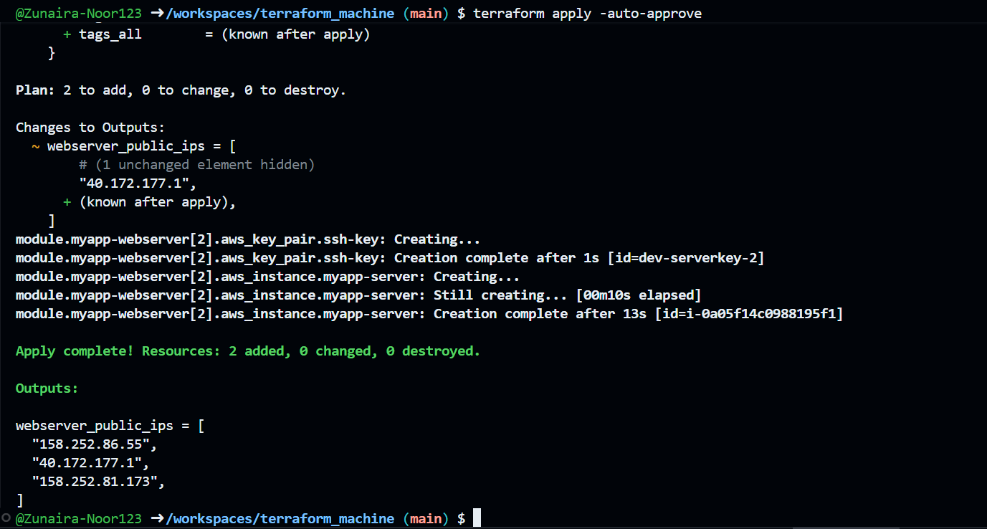

**Check outputs**:

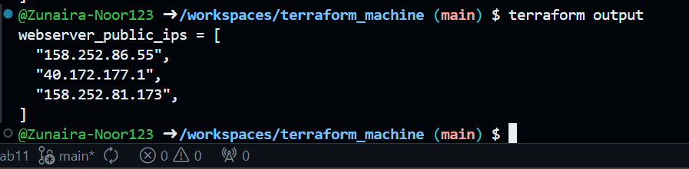

**Rewrite your hosts file** using group definitions:

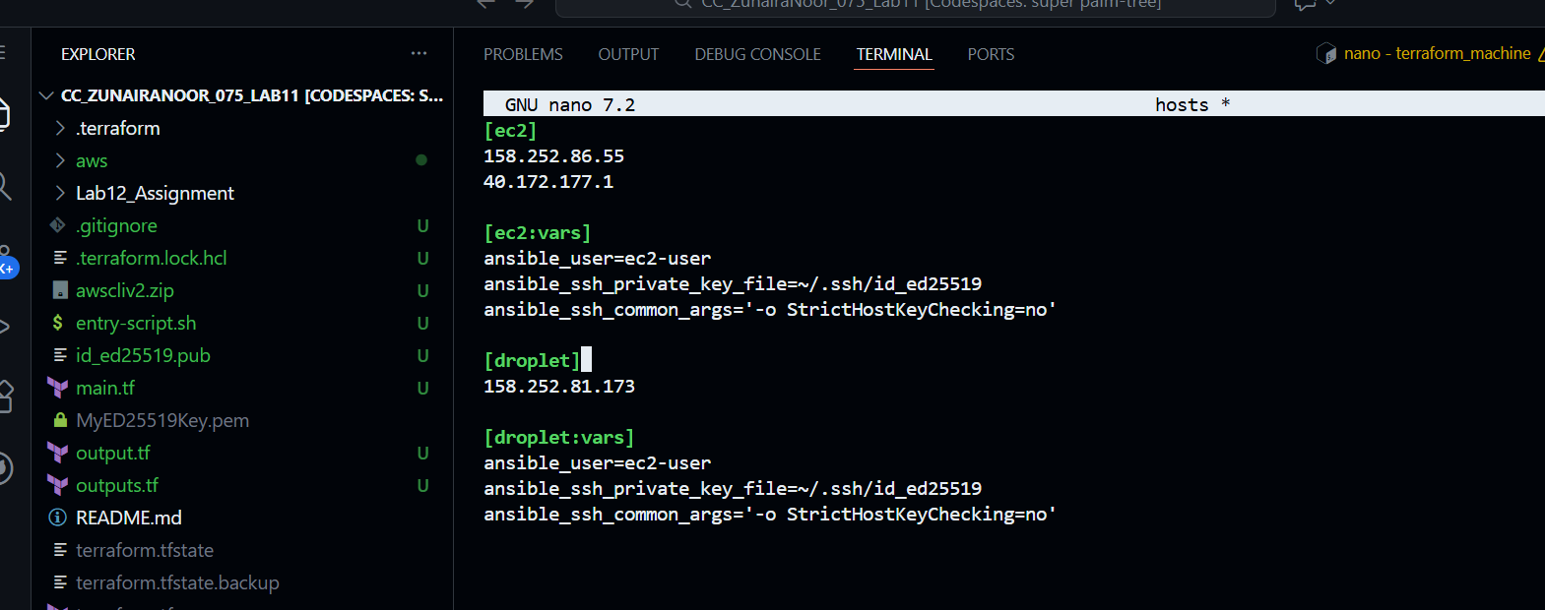

**Test group connectivity**:

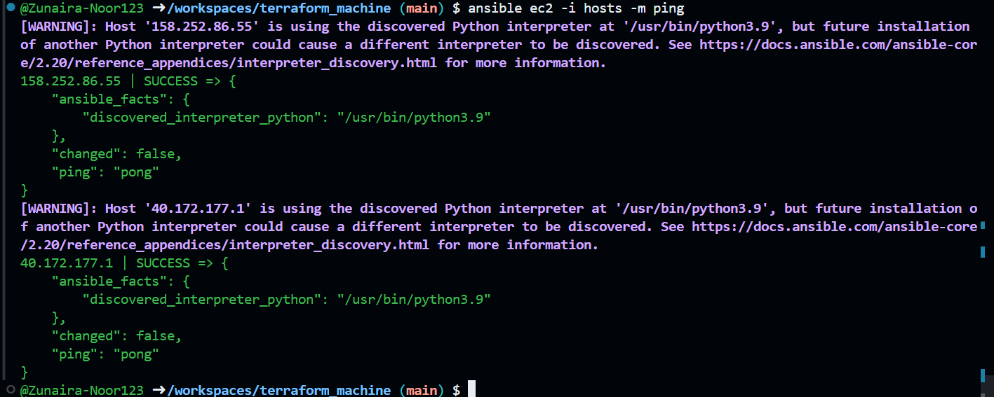

**Test single host by IP**:

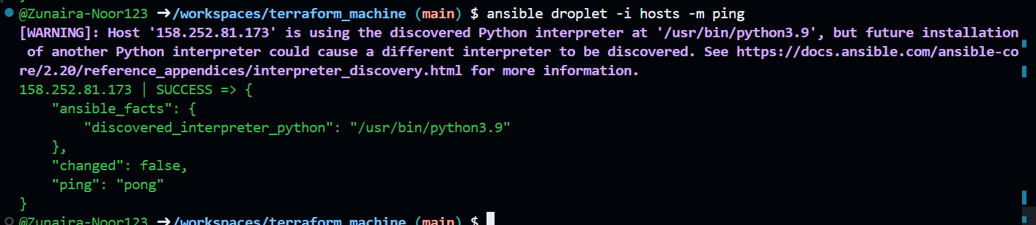

**Test all hosts**:

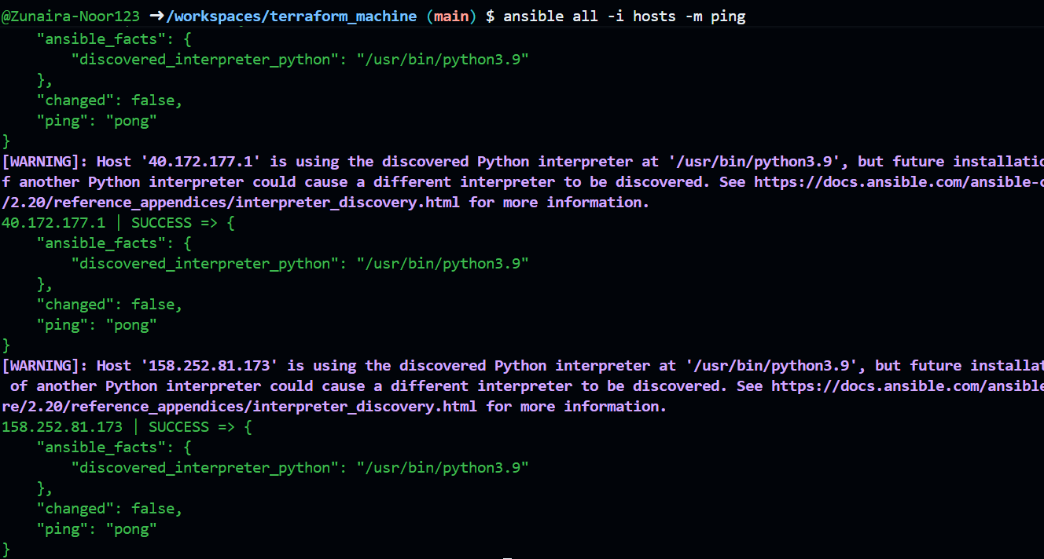

**Task 4 – Global ansible.cfg & first nginx playbook**

**Create global Ansible configuration**:

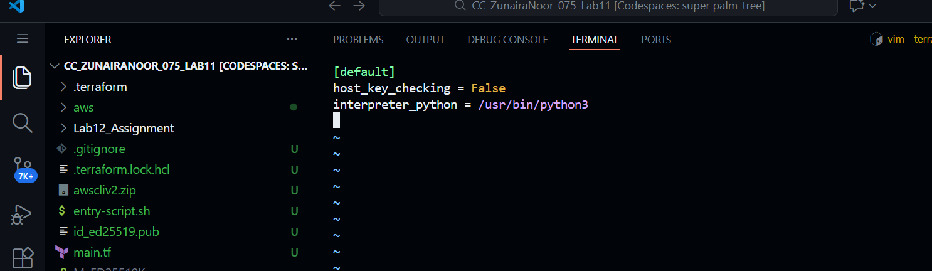 **Remove ansible_ssh_common_args** from hosts (delete from all groups).

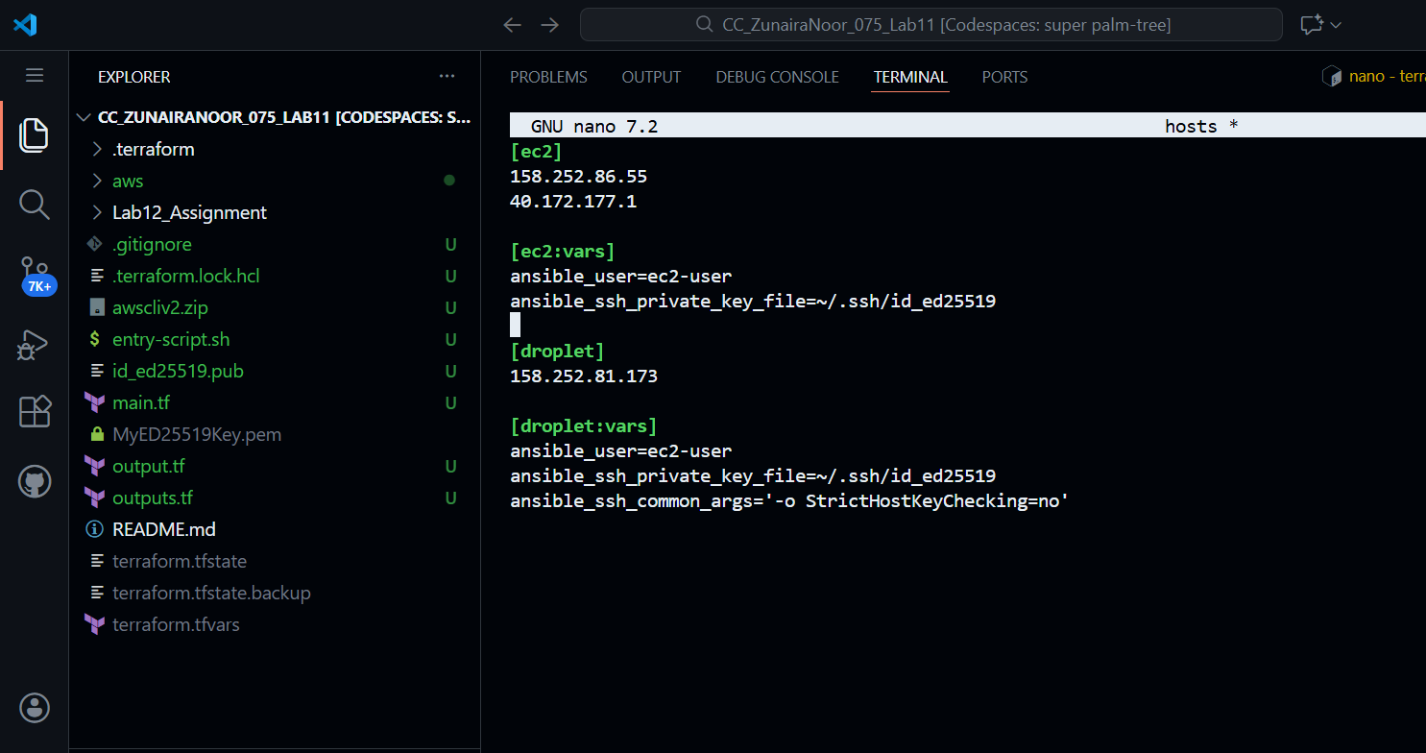

**Confirm connectivity**:

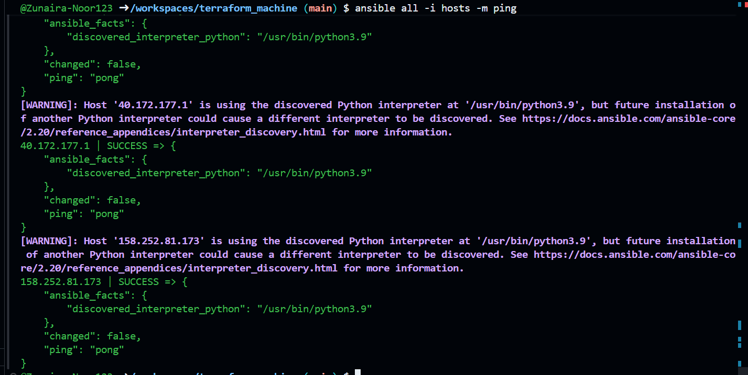

**Create my-playbook.yaml**:



Add playbook content for [ec2] group

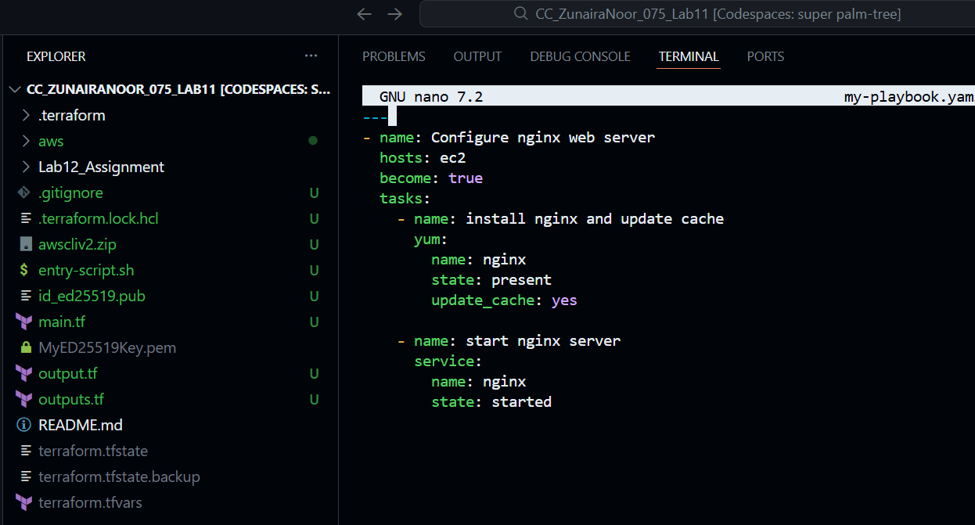

**Run the playbook on [ec2] group**

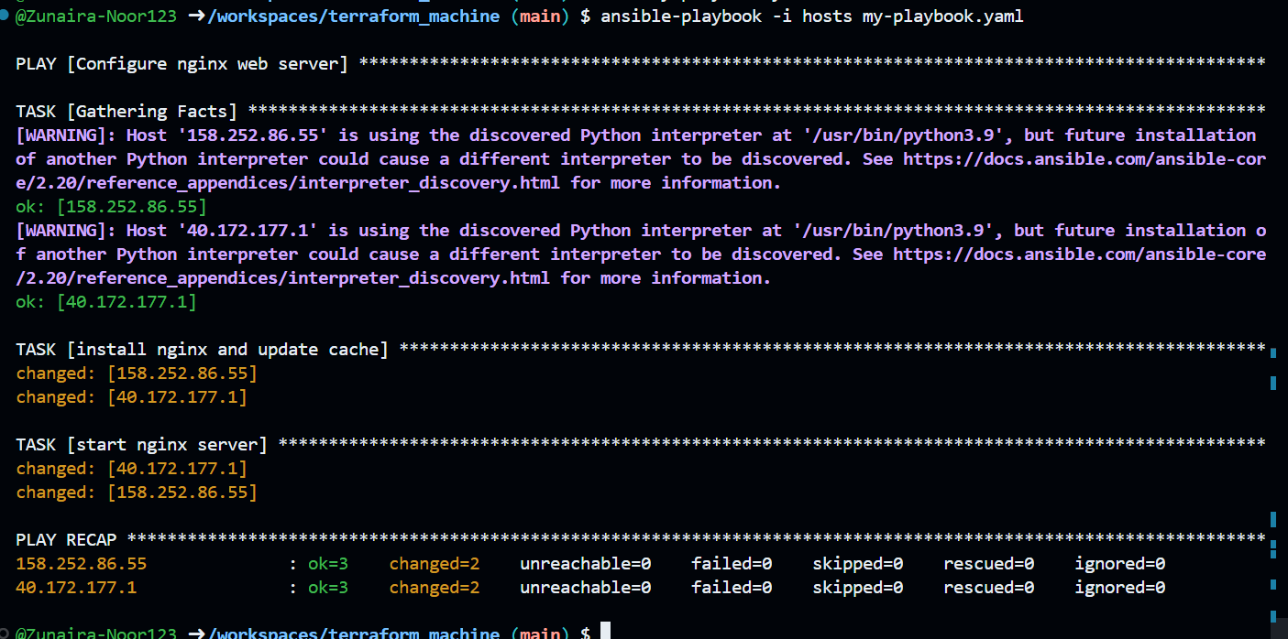

**Verify** nginx default page on [ec2] servers by visiting http://<public-ip-ec2>.

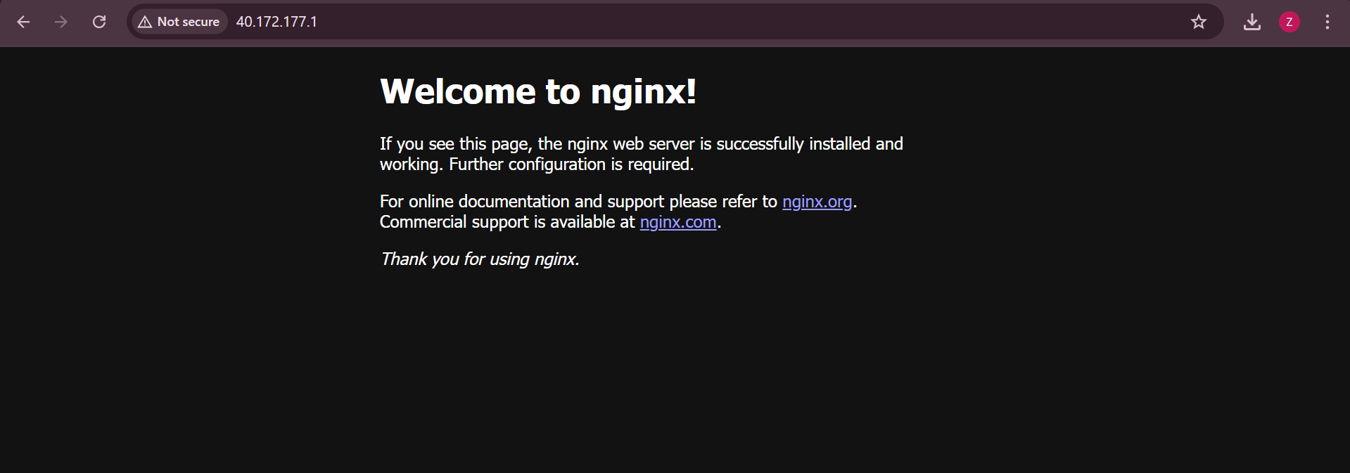

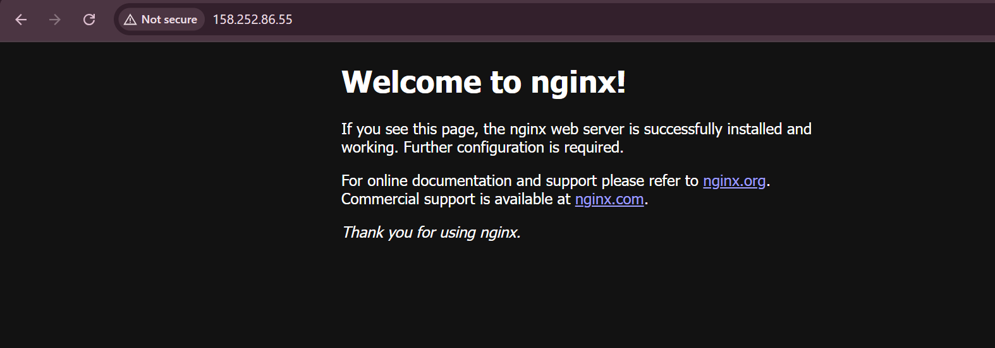

**Change target to droplet**:

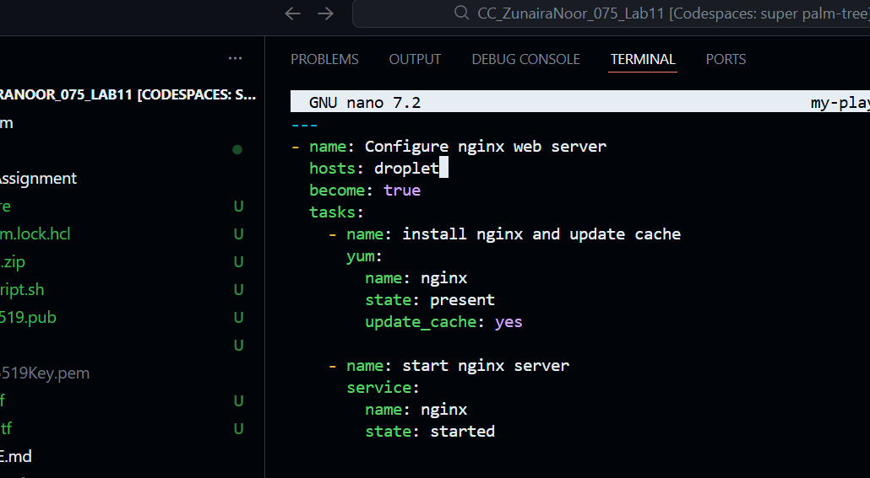

Re-run:

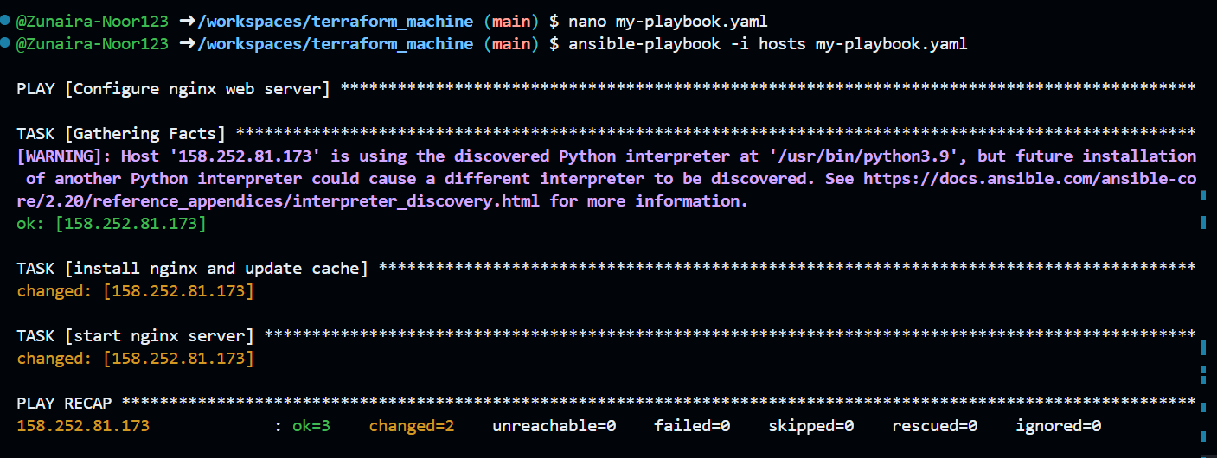

Verify nginx default page on droplet

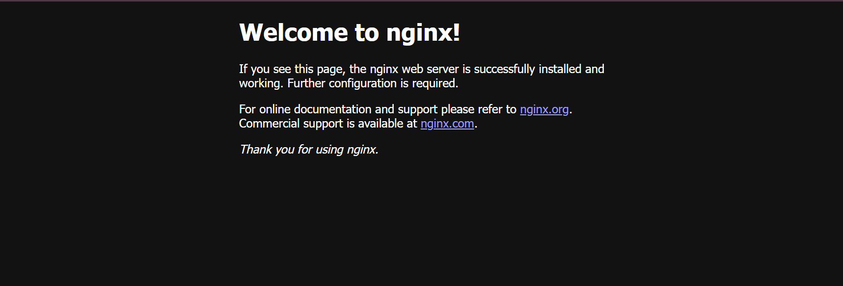

**Task 5 – Single nginx target group & HTTPS prerequisites**

**Create project‑level ansible.cfg** in repo root:

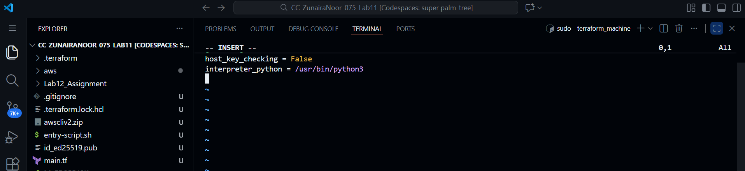

Switch Terraform EC2 count back to 1

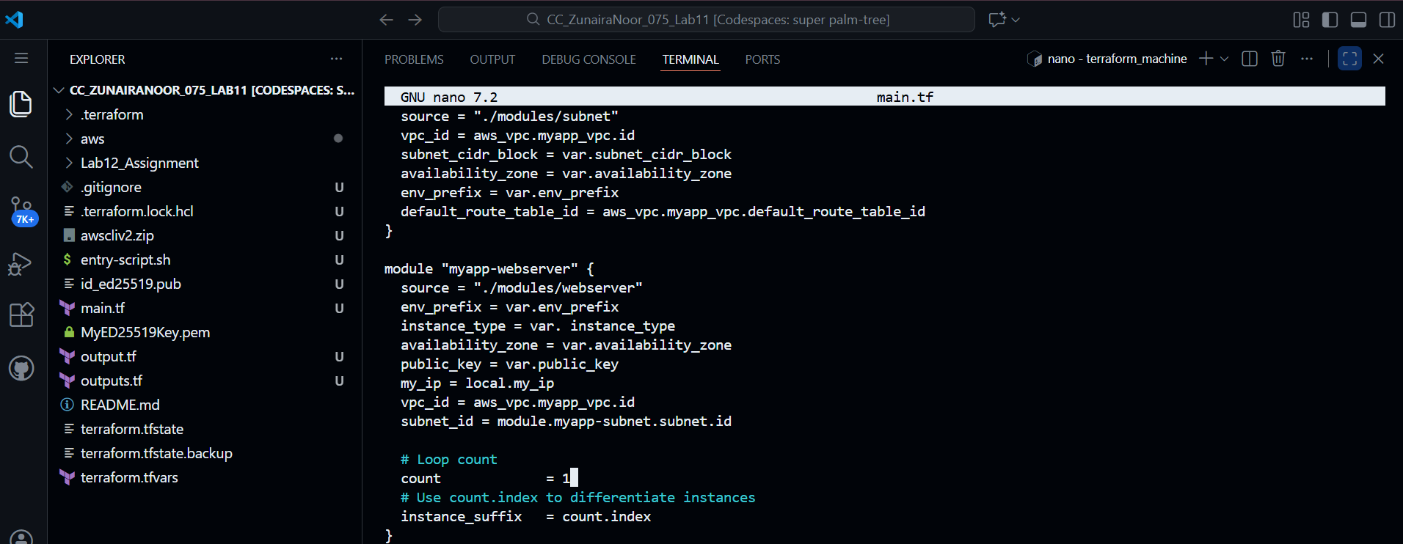

Apply Terraform

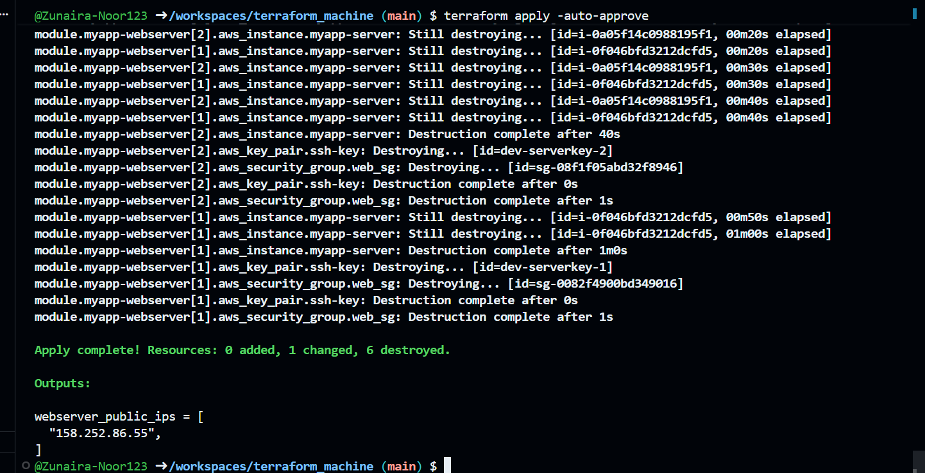

Get outputs (single public IP)

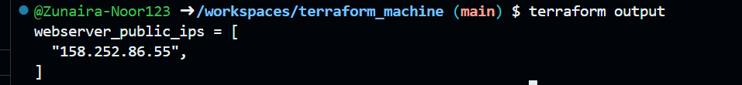

Adjust hosts file

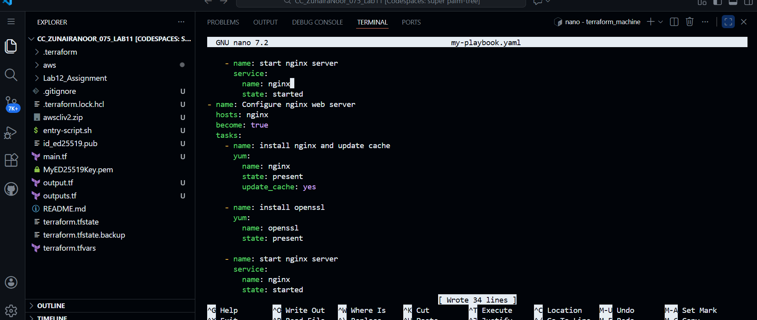 **Run the playbook**:

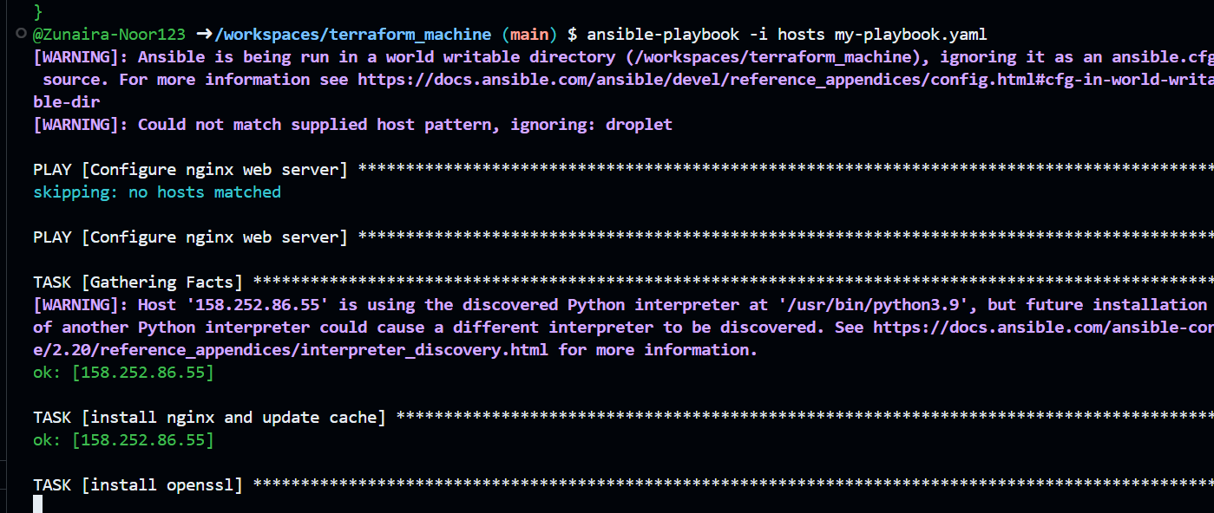

**Verify nginx default page** at http://<public-ip>



**Task 6 – Ansible‑managed SSL certificates**

Append this play after the nginx play in my-playbook.yaml:

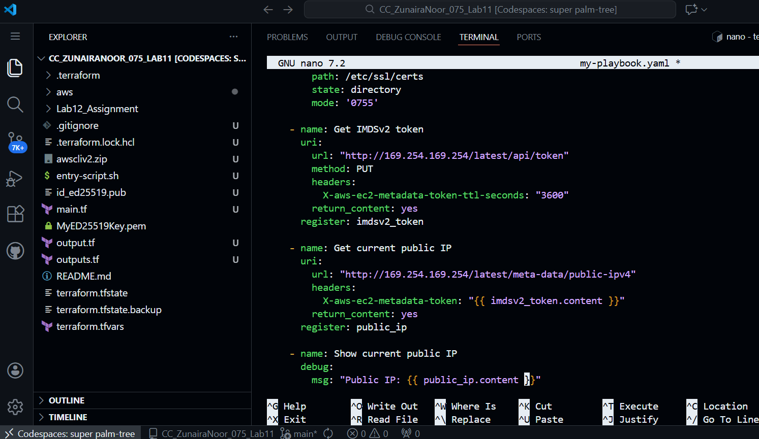

Run:

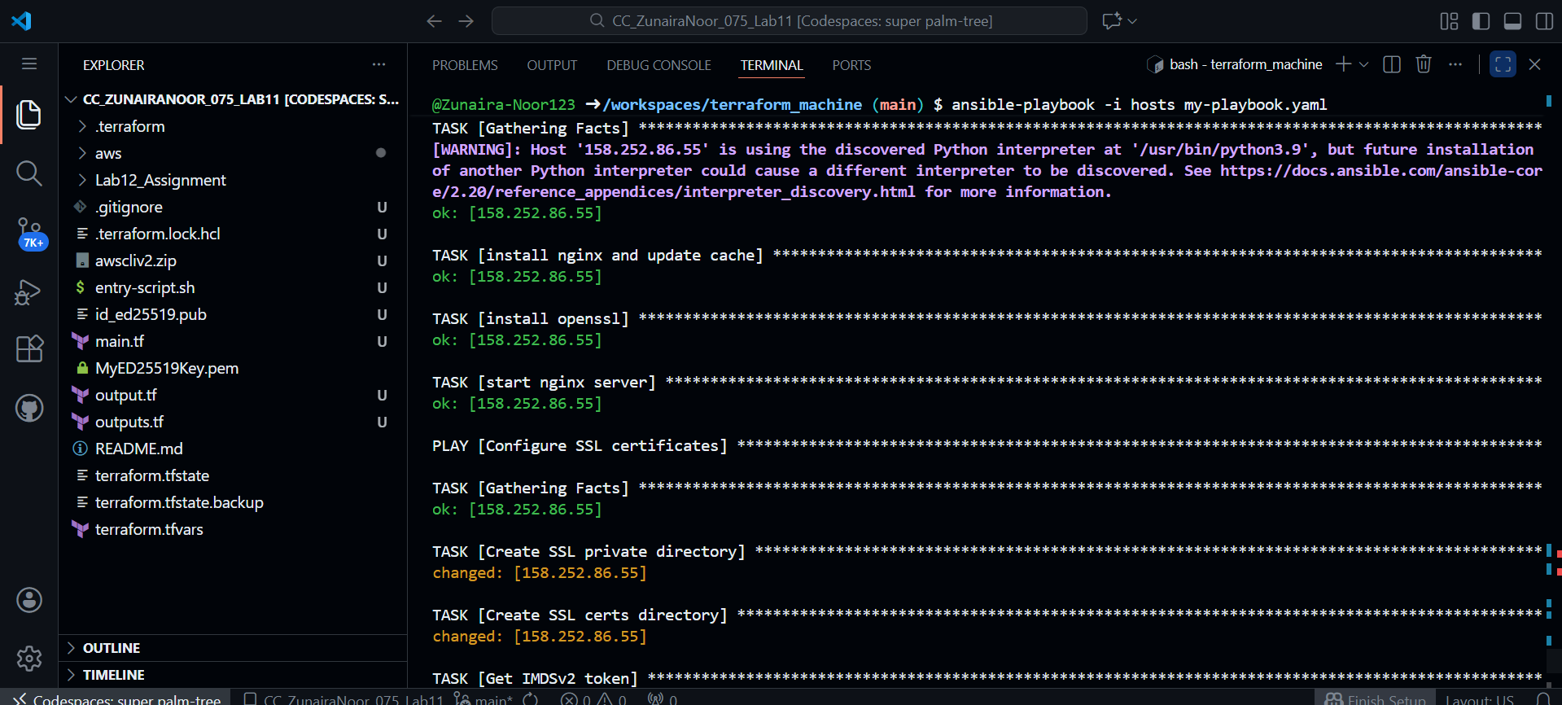

SSH and verify:

ssh ec2-user@<public-ip> -i ~/.ssh/id_ed25519

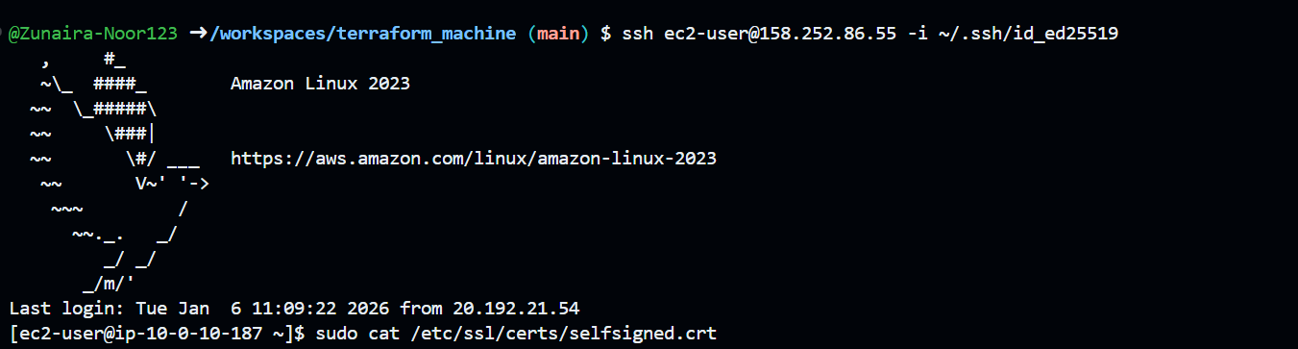

sudo cat /etc/ssl/certs/selfsigned.crt

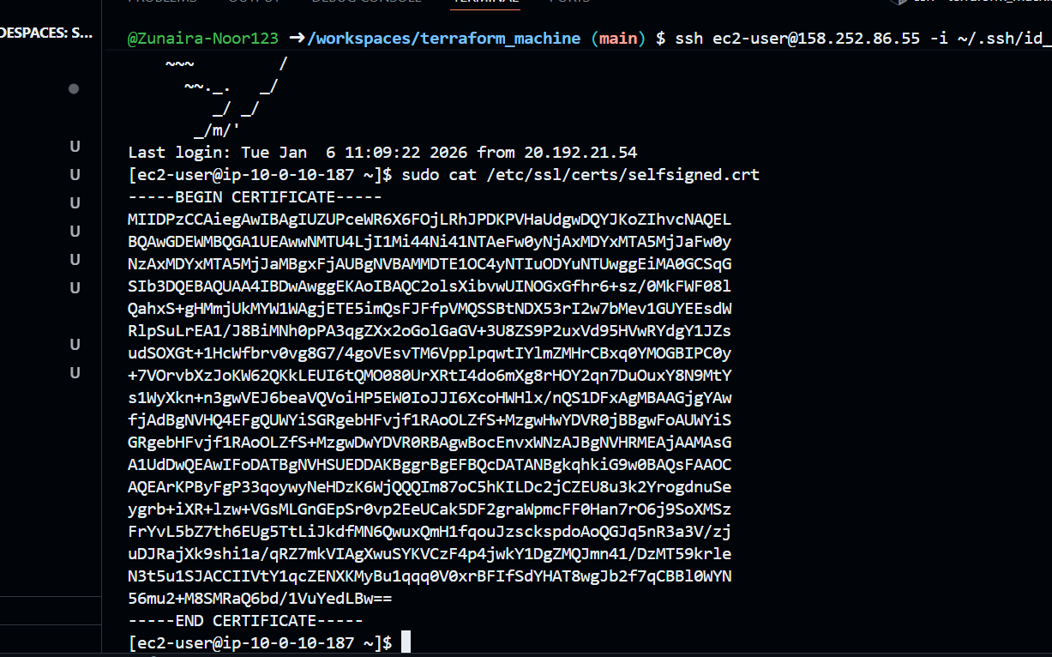

sudo cat /etc/ssl/private/selfsigned.key

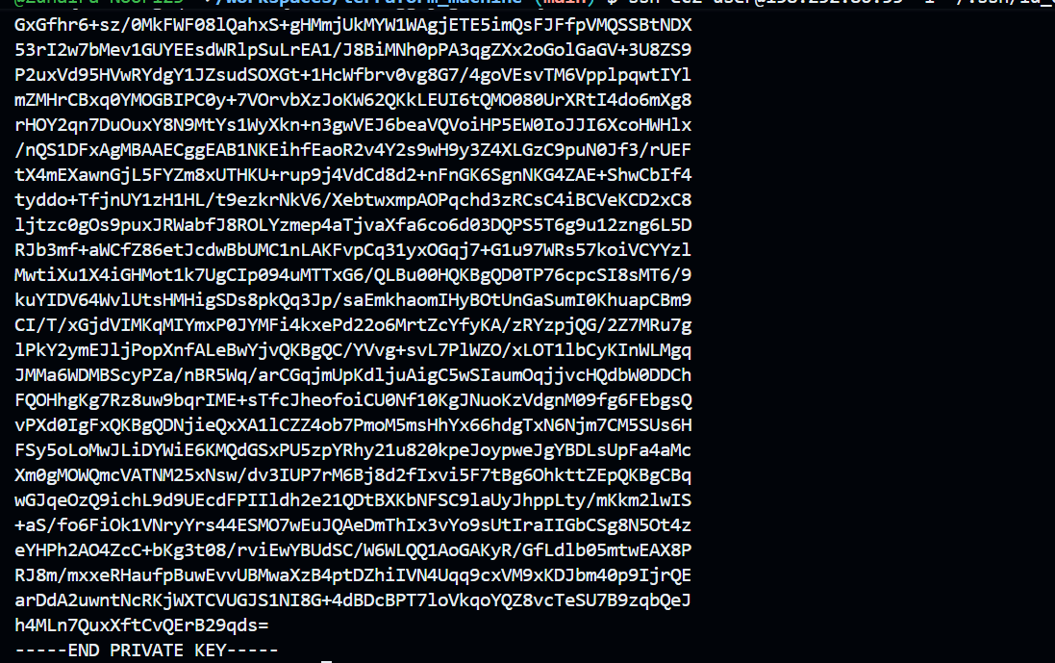

**Task 7 – PHP front‑end deployment with templates**

**Create directories and files**:

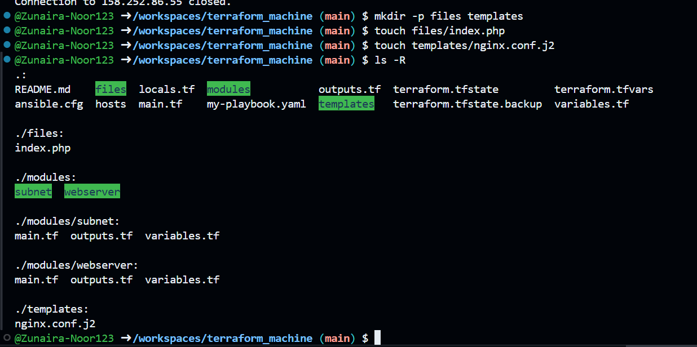

**Fill files/index.php** with the following PHP metadata page:

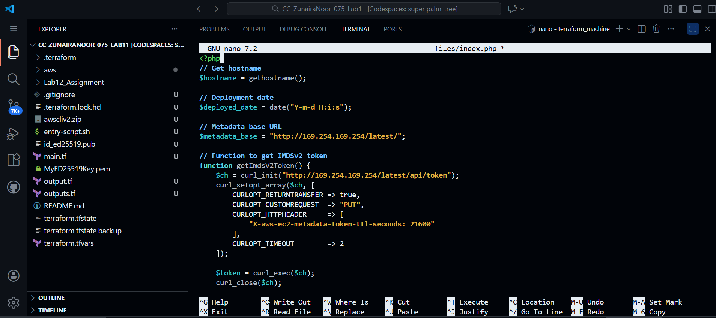

Add Nginx configuration template

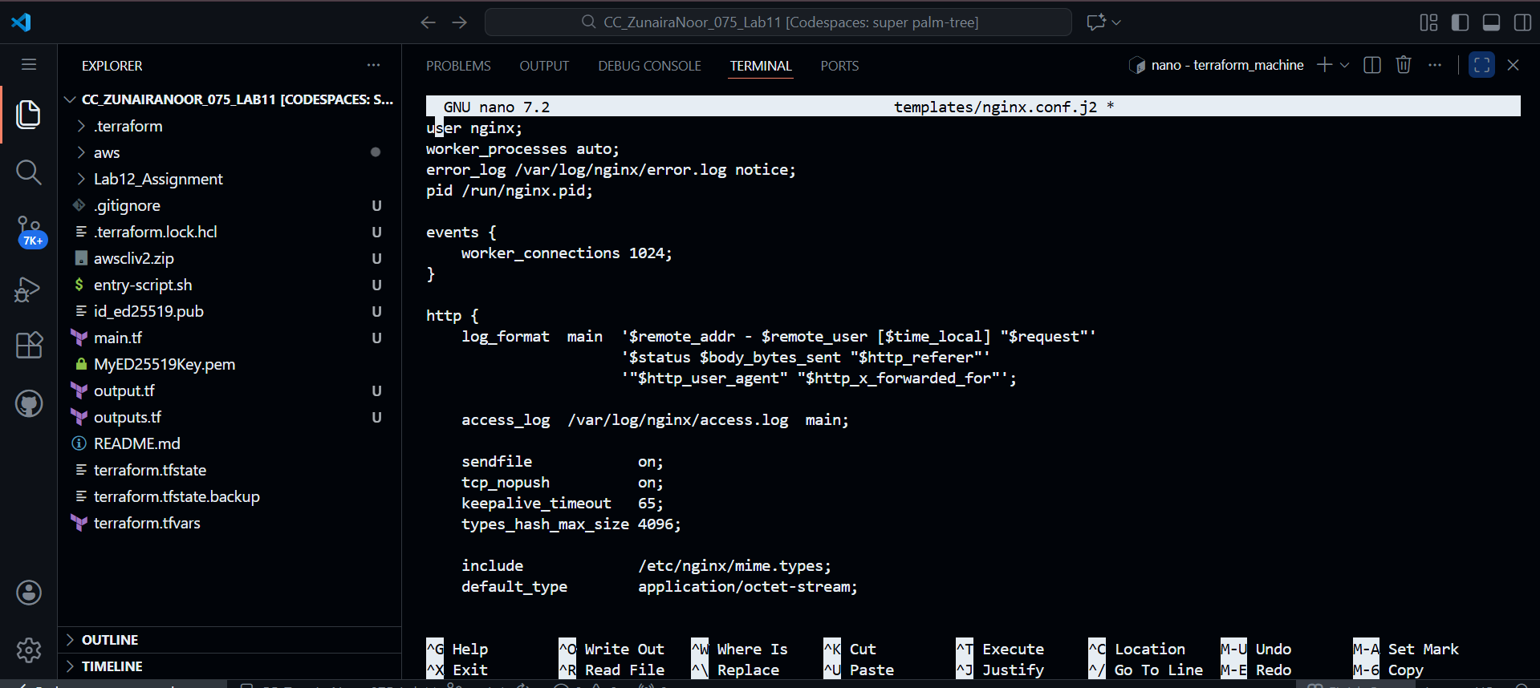

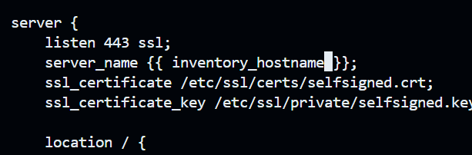

**Add this play to my-playbook.yaml**:

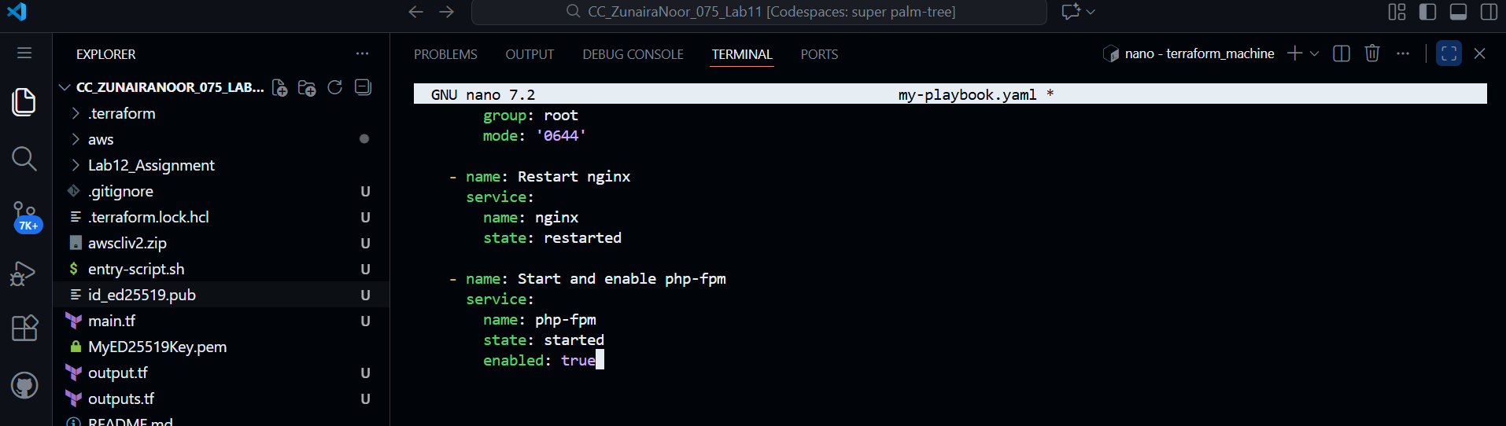

**Run the playbook**:

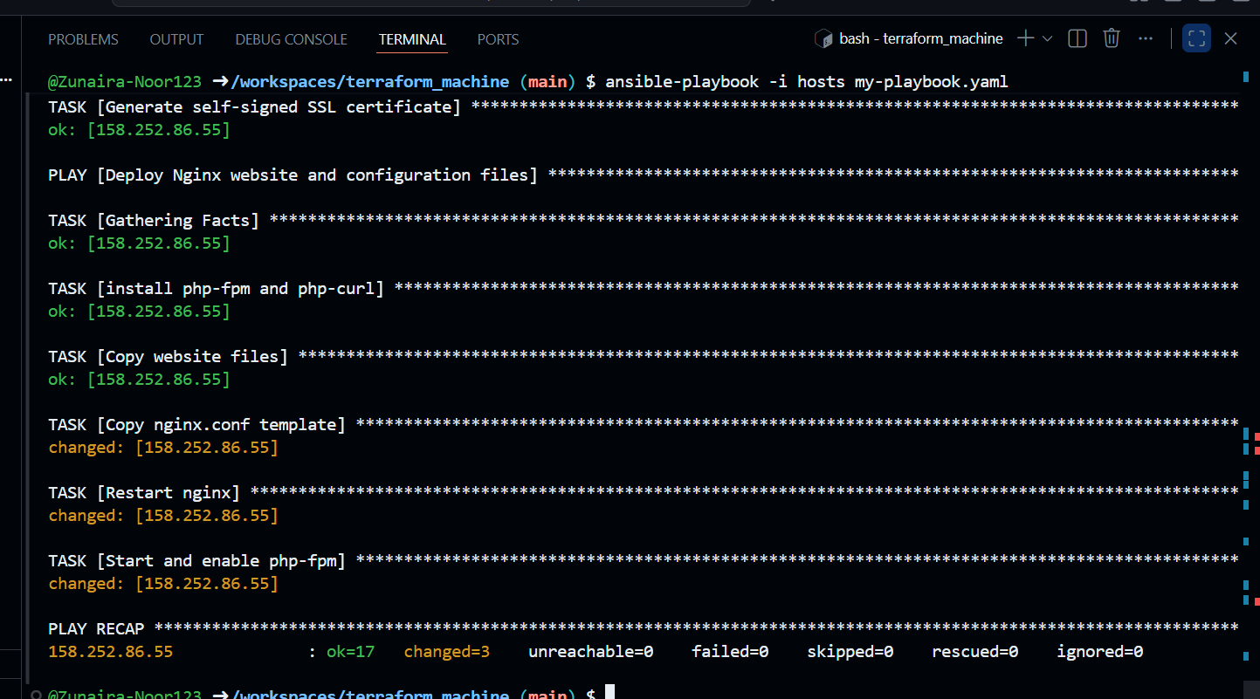

Visit https://<public-ip>:

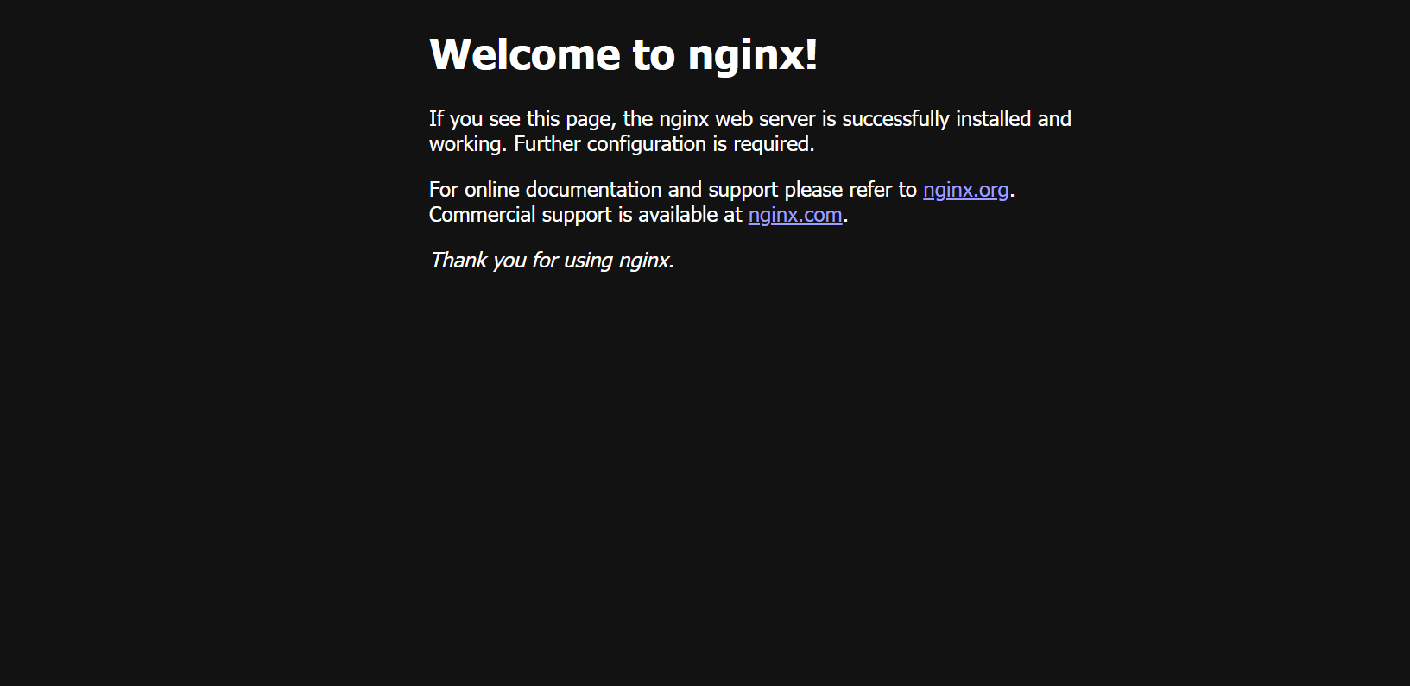

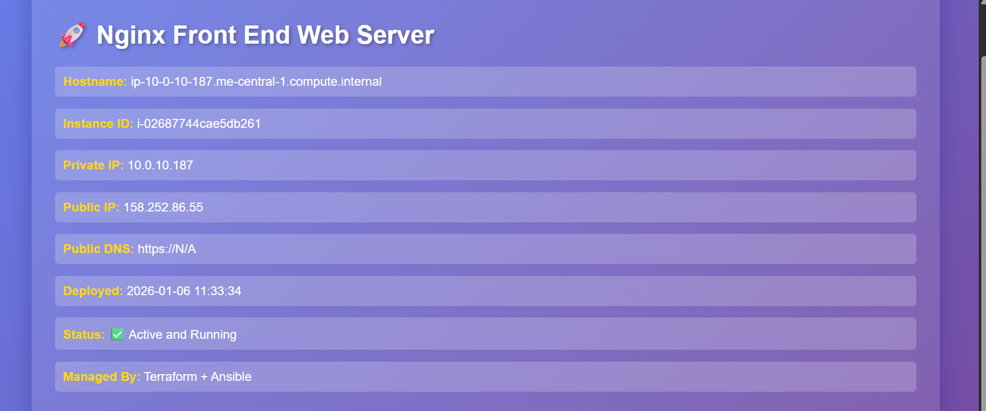

**Task 8 – Docker & Docker Compose provisioning via Ansible**

**Destroy old infrastructure**:

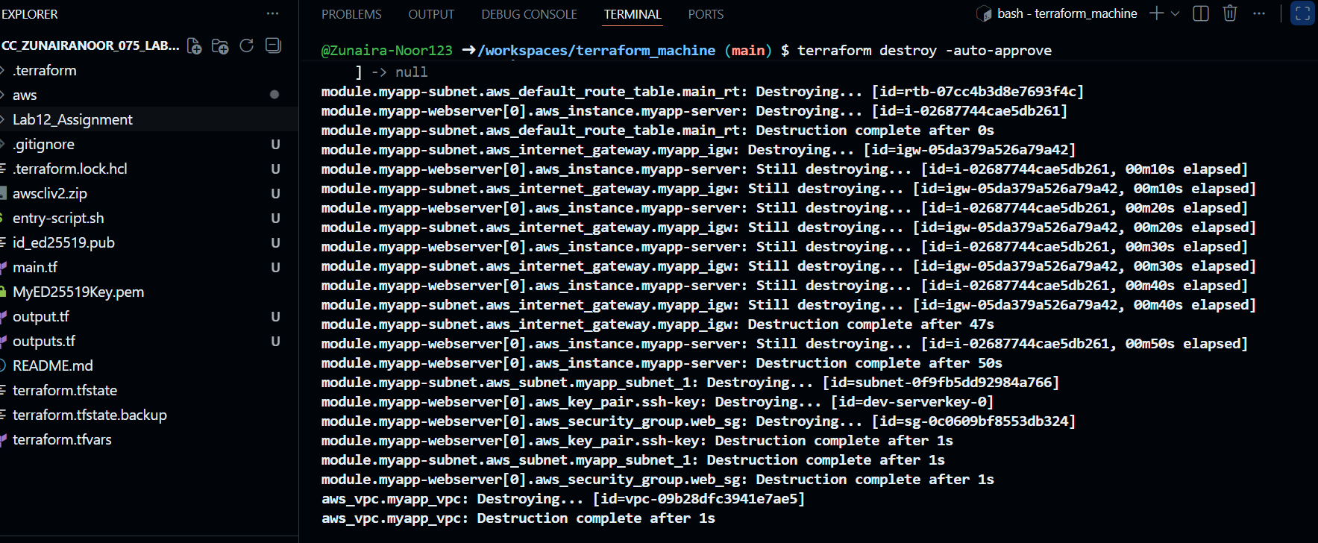

**Recreate fresh infrastructure** (1 instance):

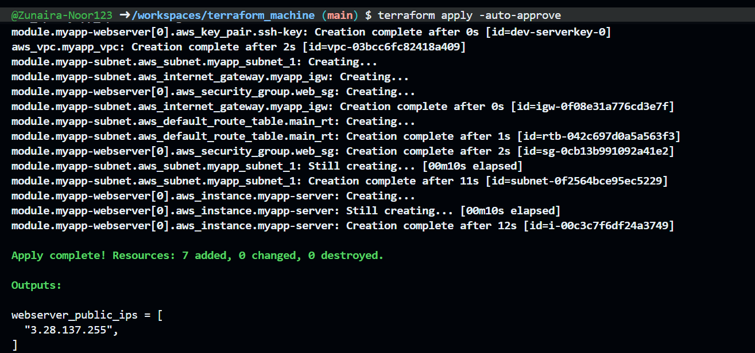

Get new public IP

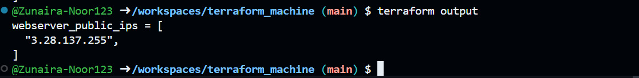

Update hosts file

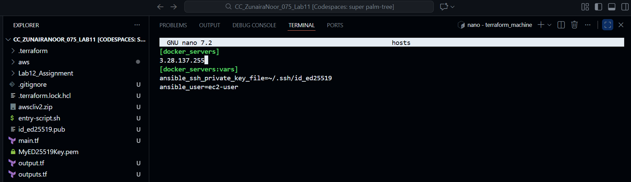

Replace my-playbook.yaml

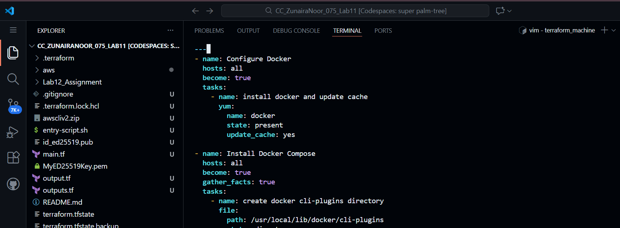

**Run the play**:

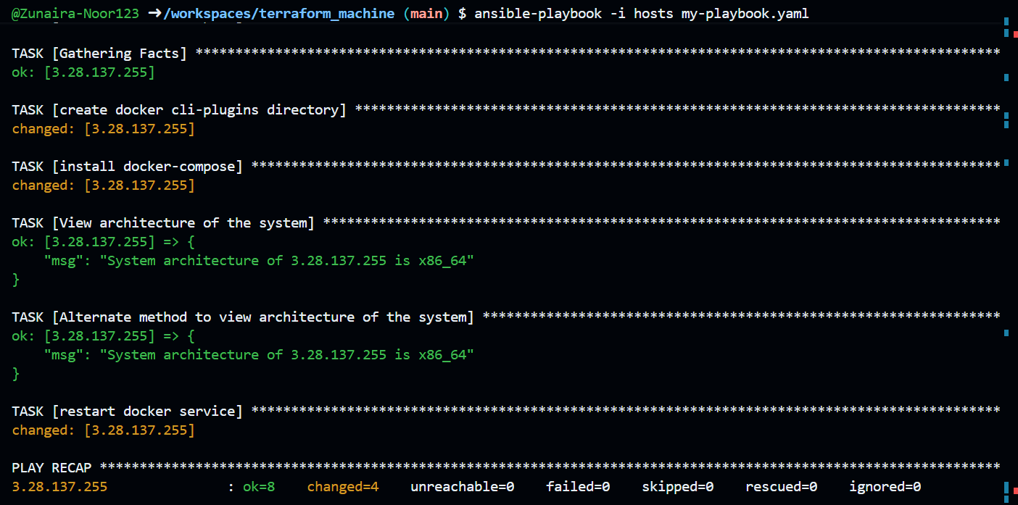

**Verify Docker**:

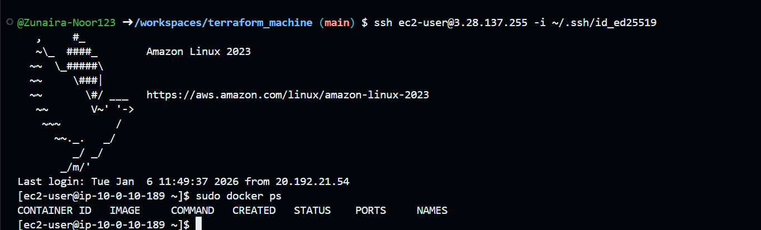

**Task 9 – Gitea Docker stack via Ansible + Terraform security group update**

**Extend my-playbook.yaml** by appending:

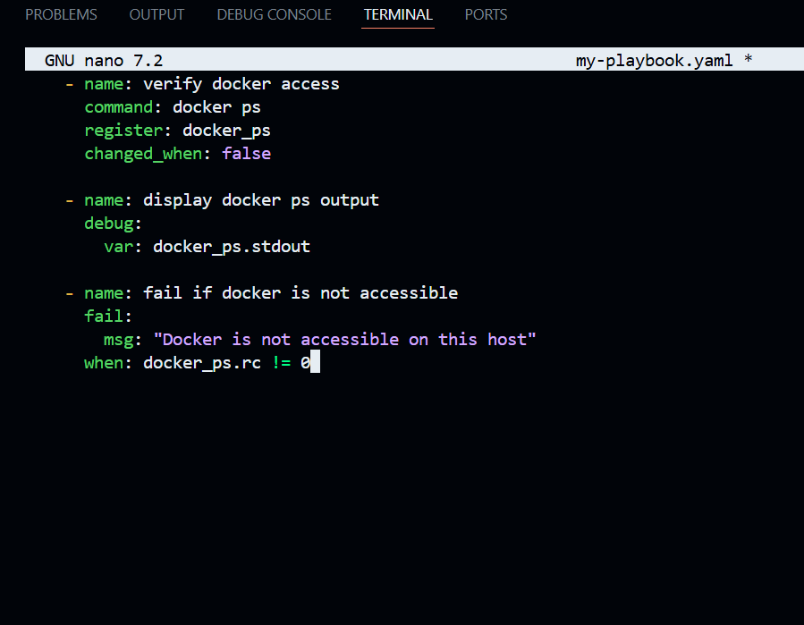

**Create project-vars.yaml**

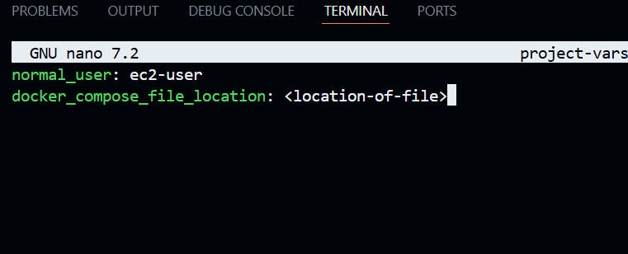

**Add the deploy containers play**:

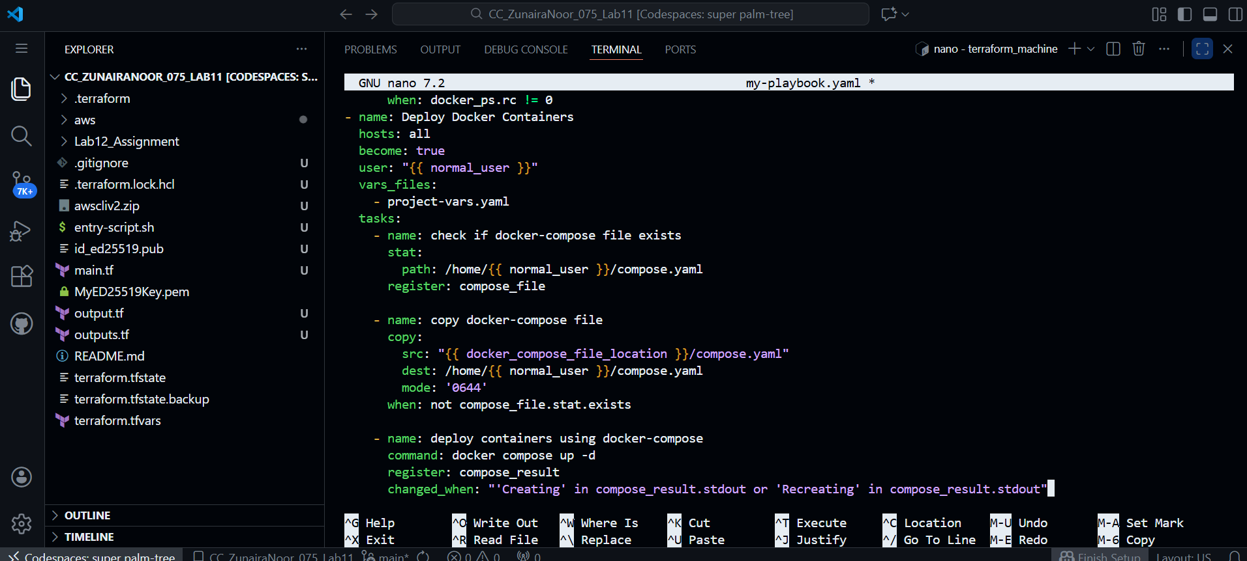

**Create compose.yaml** in repo root:

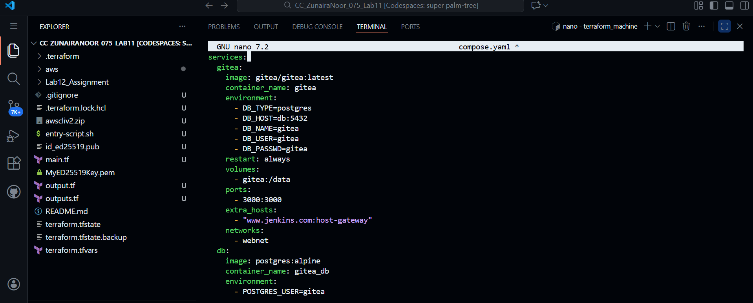

Run Ansible playbook

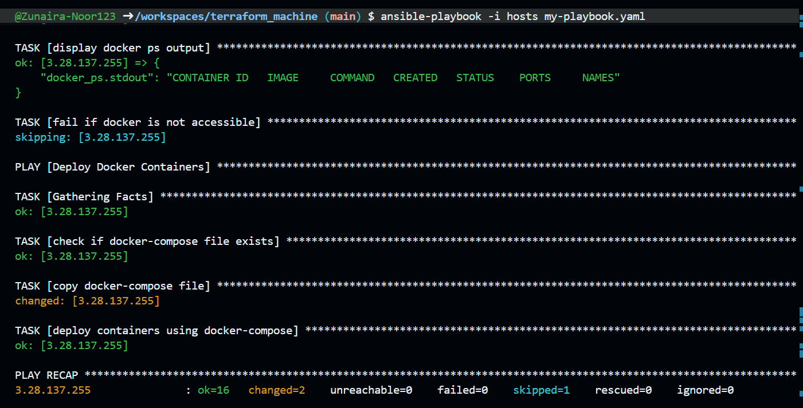

**Update security group** in modules/webserver/main.tf to add port 3000:

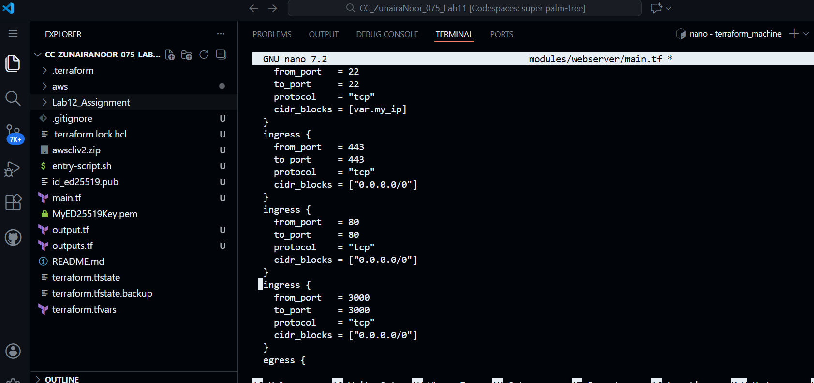

Apply:

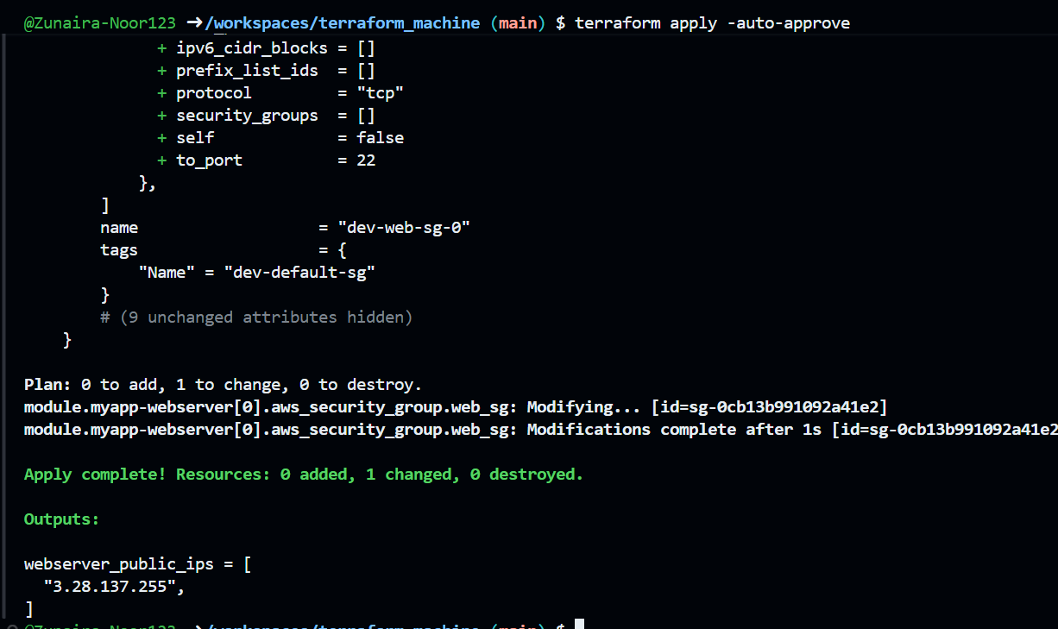

**Access Gitea**:

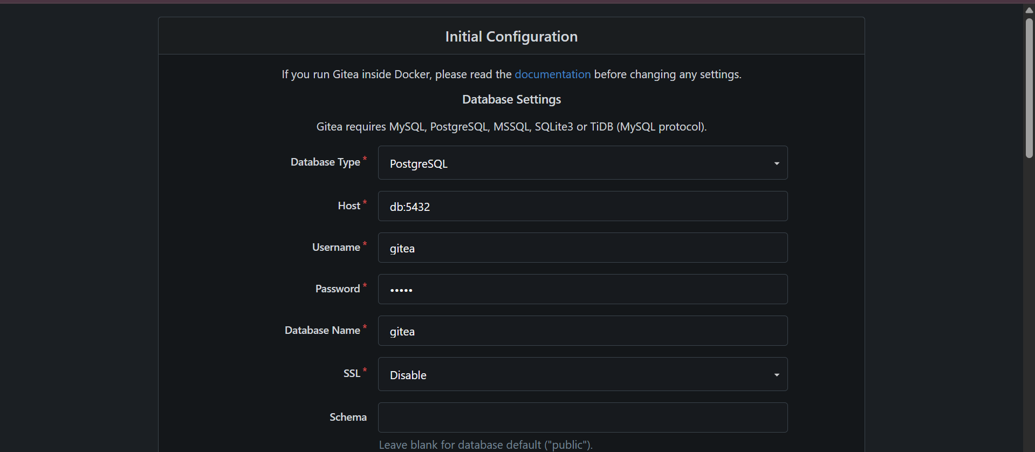

**Task 10 – Automating Ansible with Terraform (null_resource)**

**Add null_resource** to main.tf:

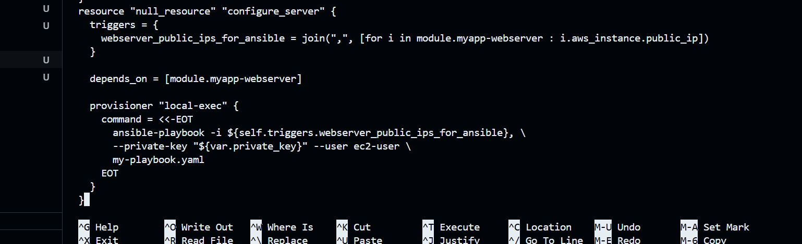

**Destroy and recreate** infrastructure:

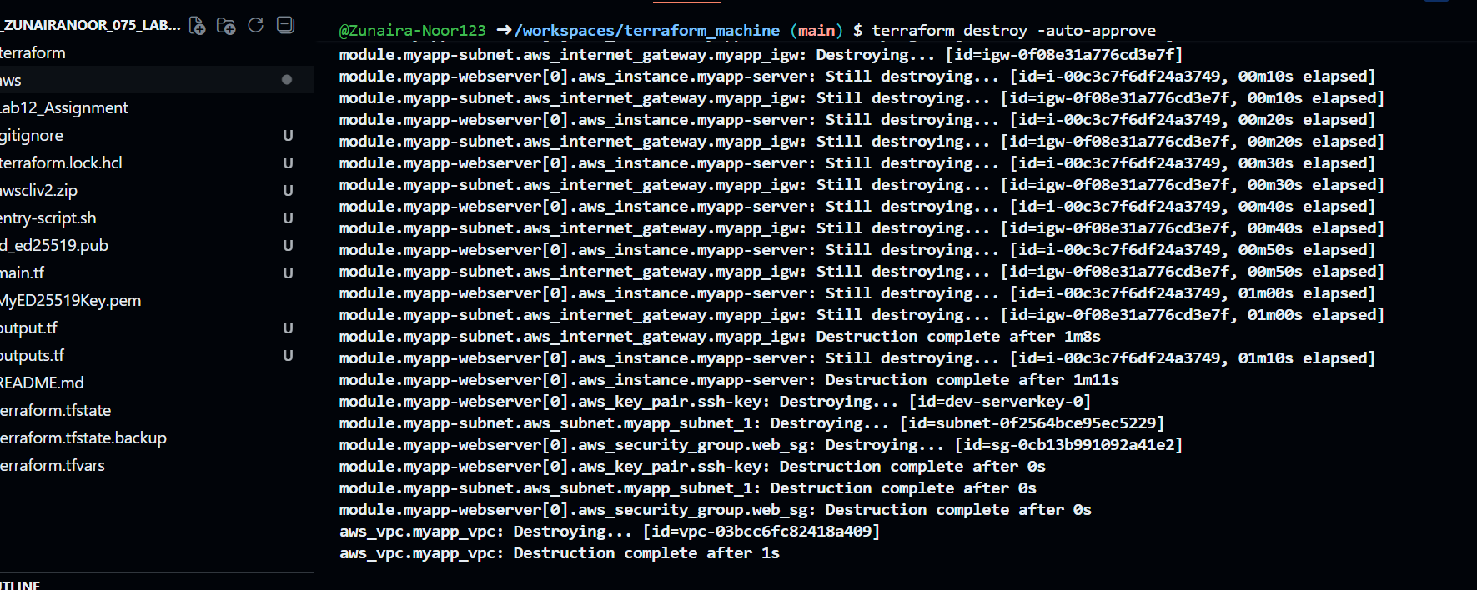

If Ansible fails due to readiness, **add a wait play** at the top of my-playbook.yaml:

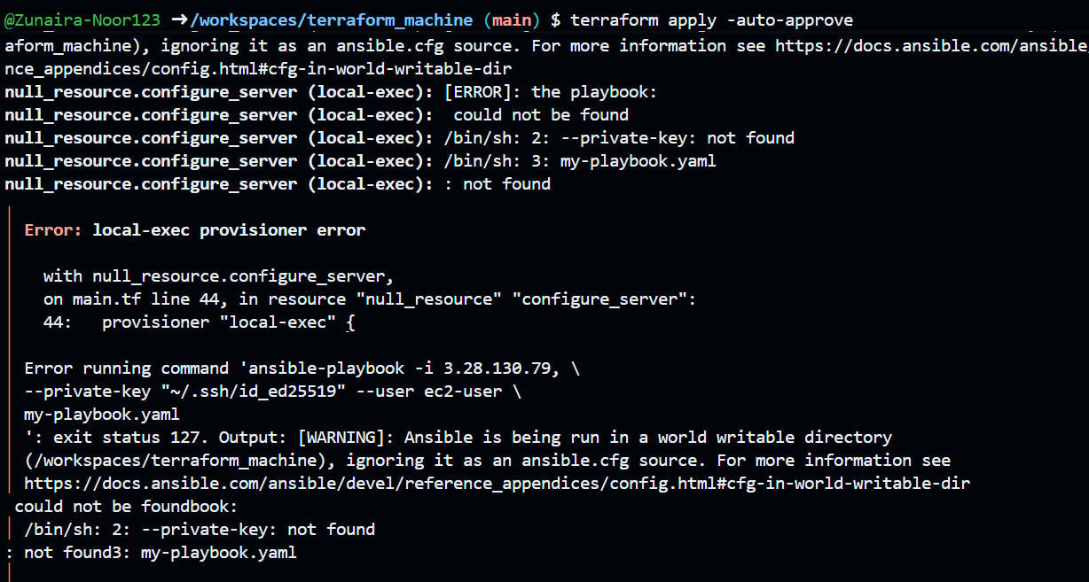

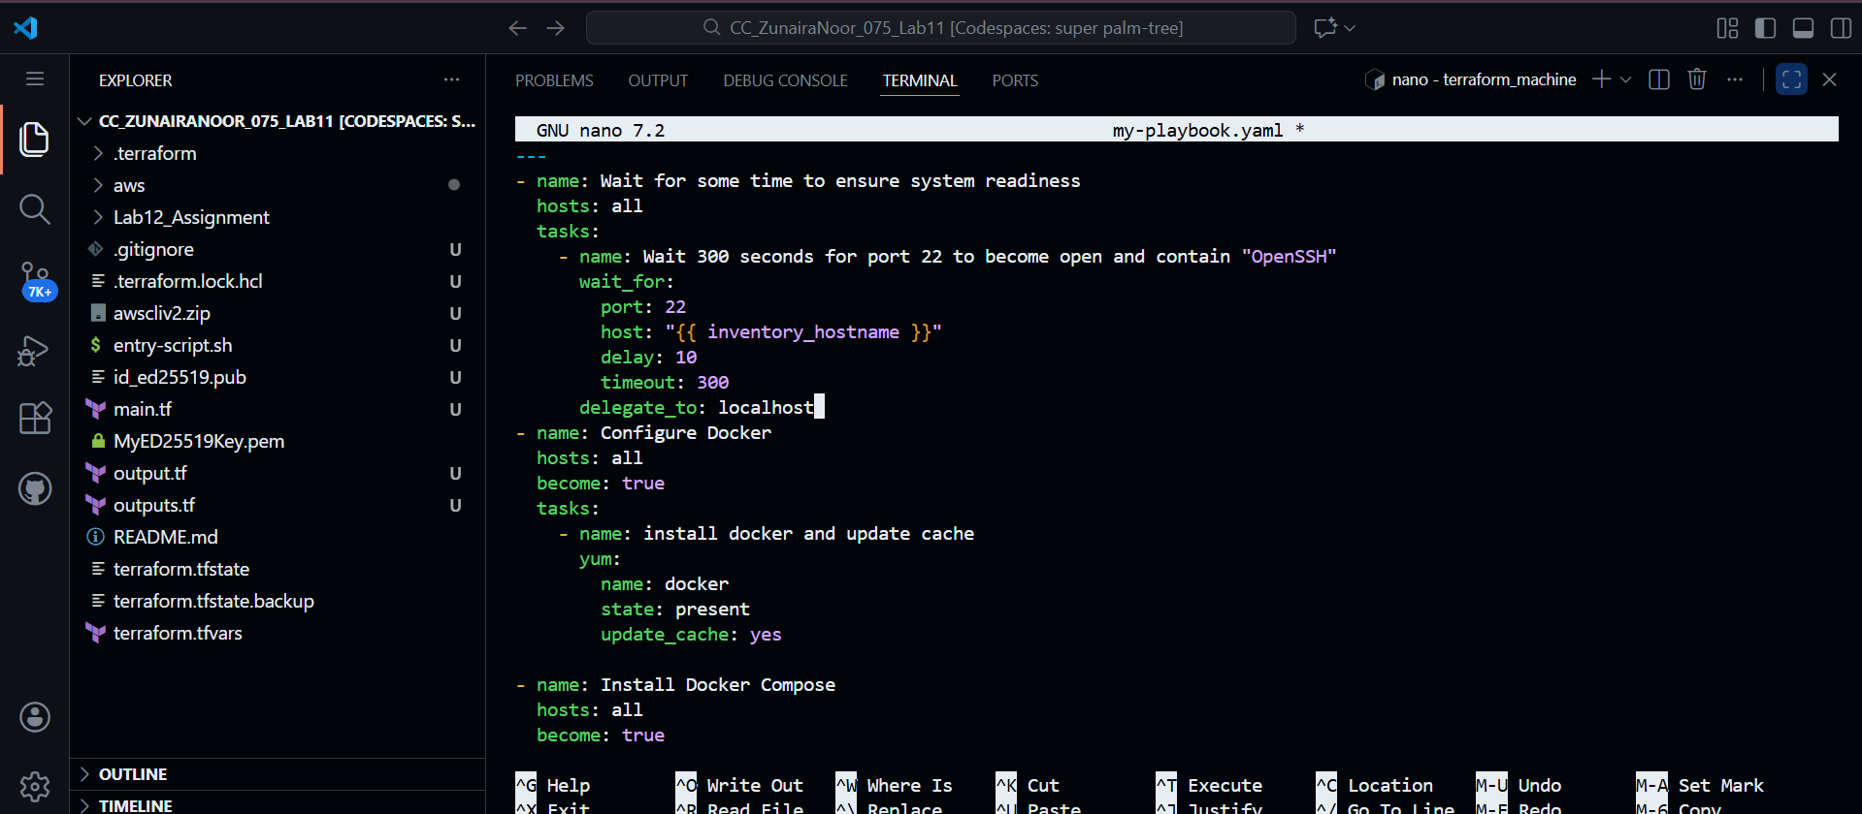

**Destroy and apply again**:

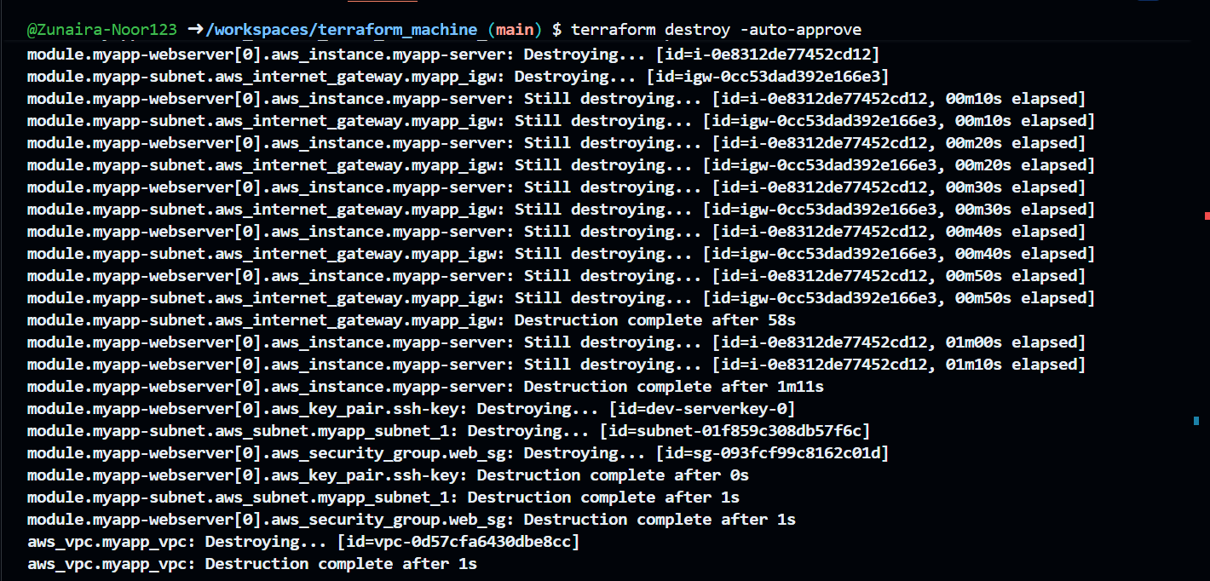

resource "null_resource" "configure_server" {

triggers = {

webserver_public_ips_for_ansible = join(",", [for i in module.myapp-webserver : i.aws_instance.public_ip])

}

depends_on = [module.myapp-webserver]

provisioner "local-exec" {

environment = {

ANSIBLE_HOST_KEY_CHECKING = "False"

}

# Single-line command avoids line-break parsing issues

command = "sleep 60 && ansible-playbook -i ${self.triggers.webserver_public_ips_for_ansible}, --private-key ${var.private_key} --user ec2-user my-playbook.yaml"

}

}

Verify Gitea / Nginx application is reachable at the appropriate URL

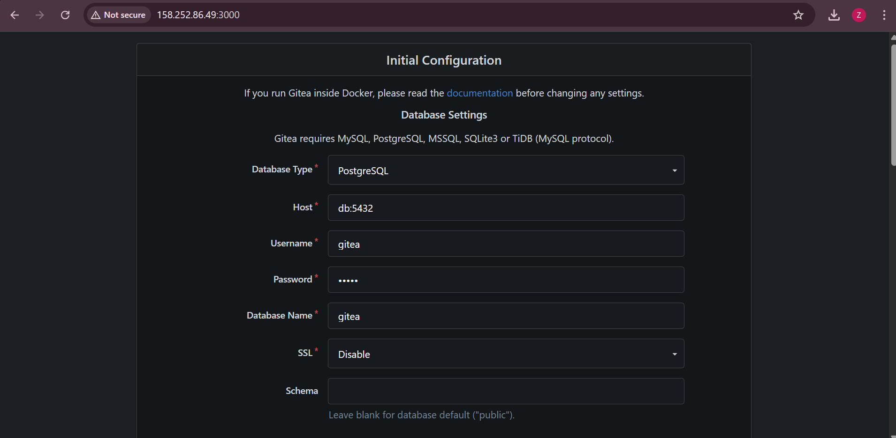

**Task 11 – Dynamic inventory with aws_ec2 plugin**

**Update ansible.cfg:**

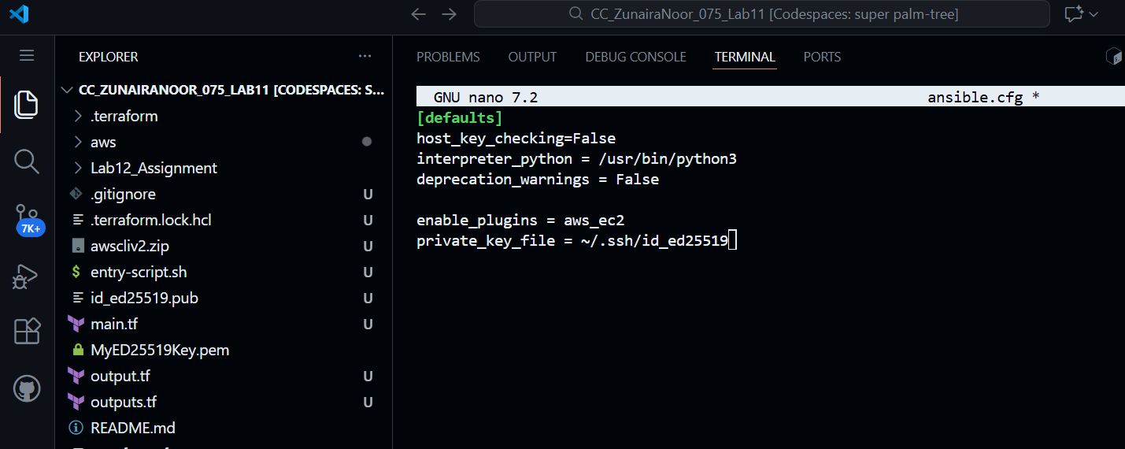

**Create inventory_aws_ec2.yaml**:



Add initial content:

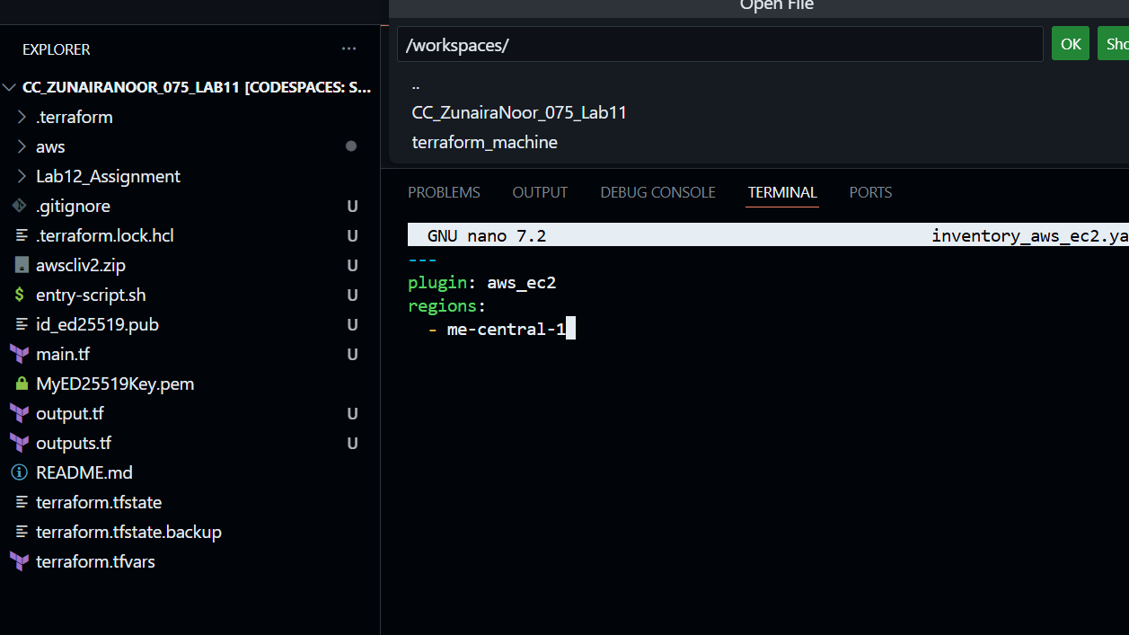

**Ensure Terraform code** includes both dev and prod webservers in **main.tf**:

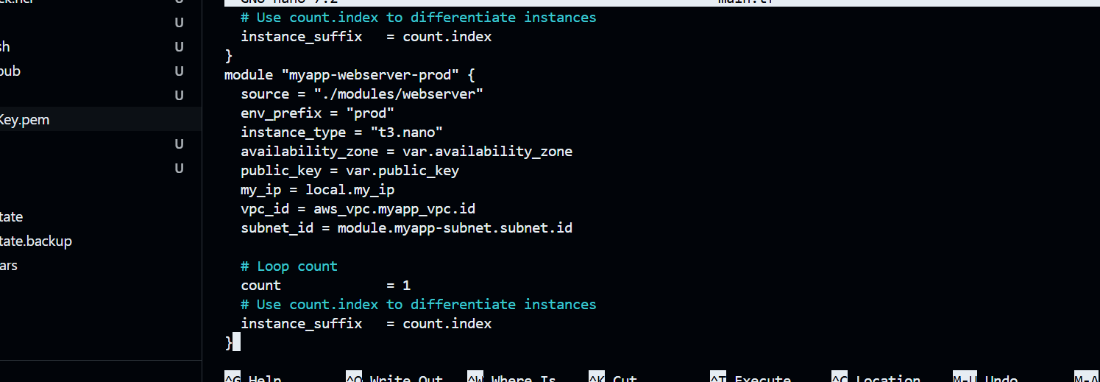

**Add outputs in outputs.tf**:

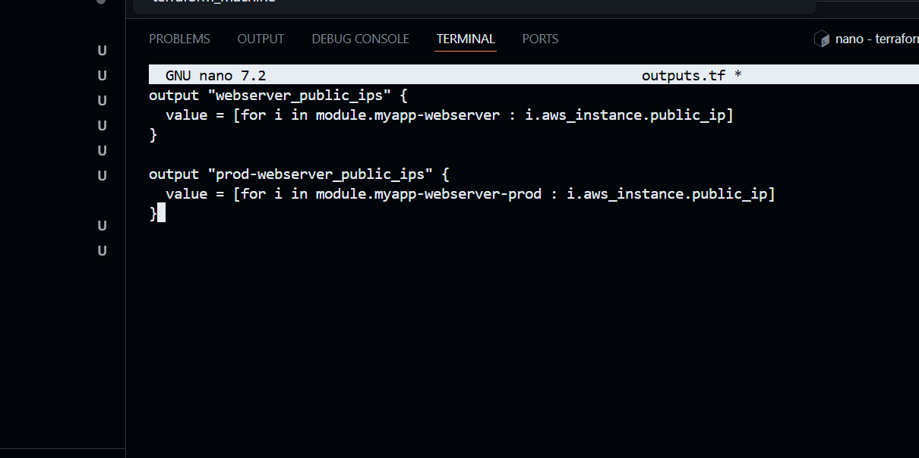

**Rebuild infra**:

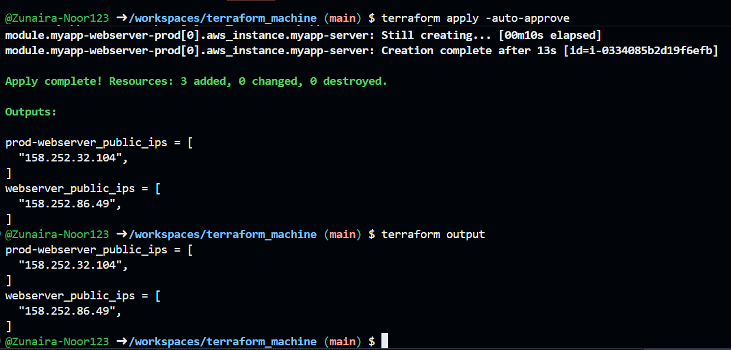

**Install boto3 and botocore**:

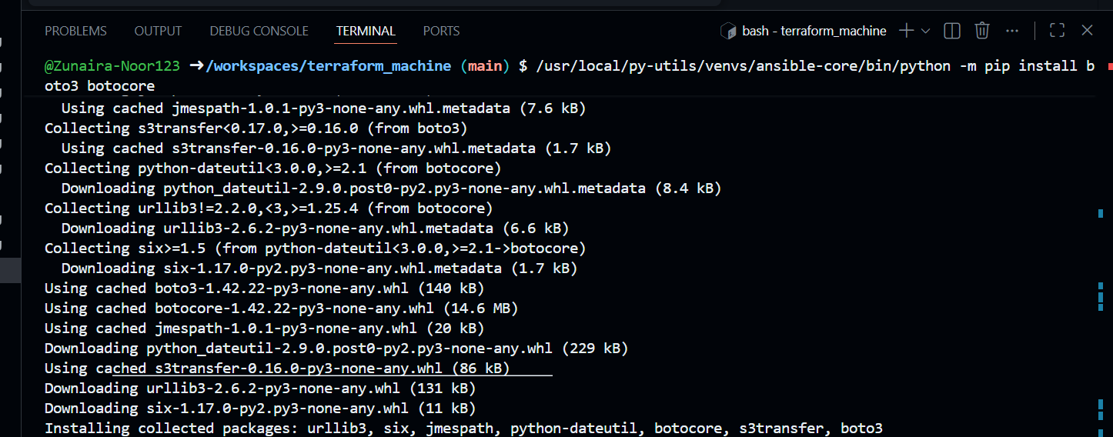



**Check inventory graph**:

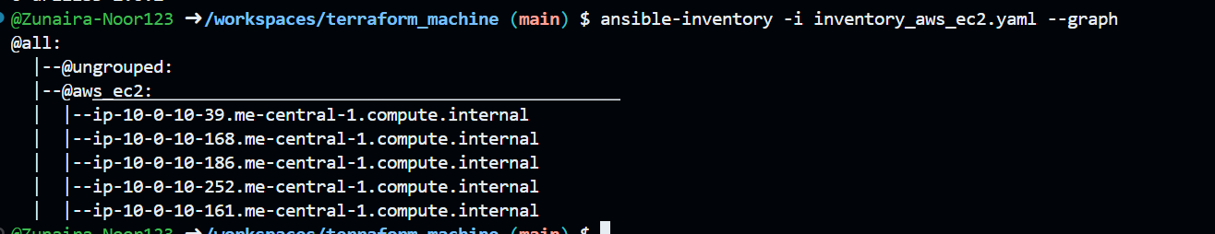

**Task 12 – Filtering EC2 instances by tags & instance type**

**Modify inventory_aws_ec2.yaml** to add tag‑based grouping:

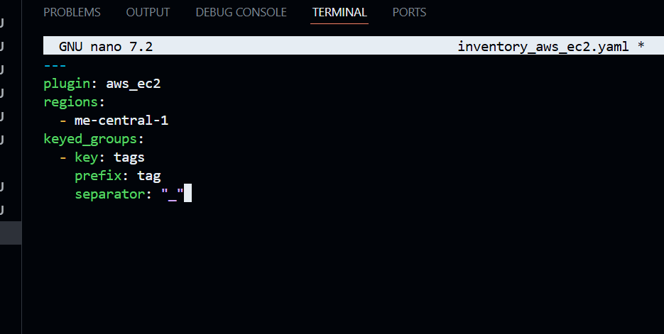

Check graph:

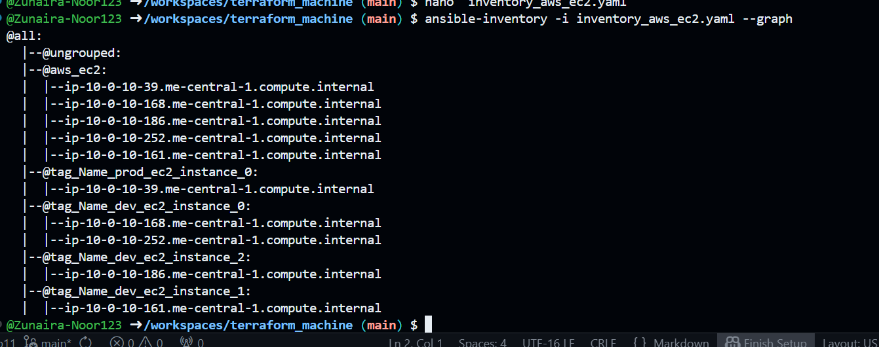

**Extend to group by instance type as well**:

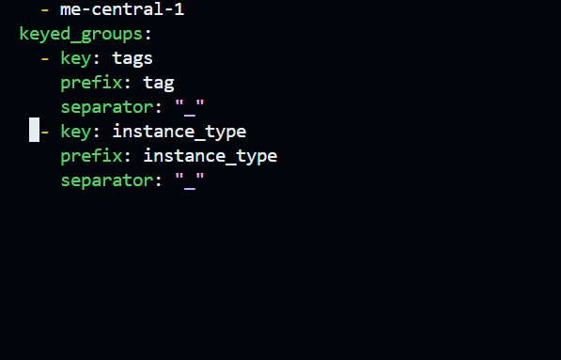

Check graph again:

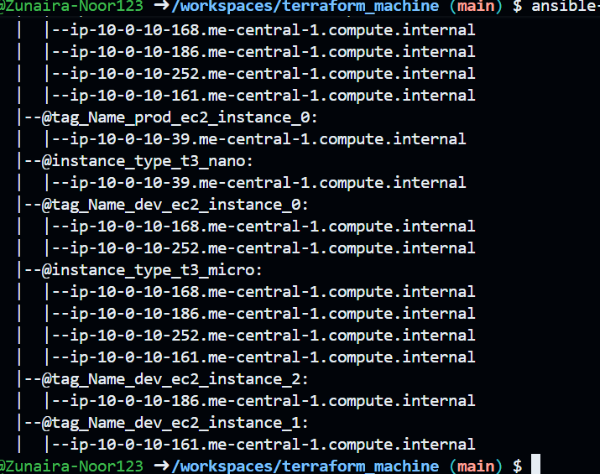

**Prepare my-playbook.yaml** for nginx+SSL+PHP on hosts: all:

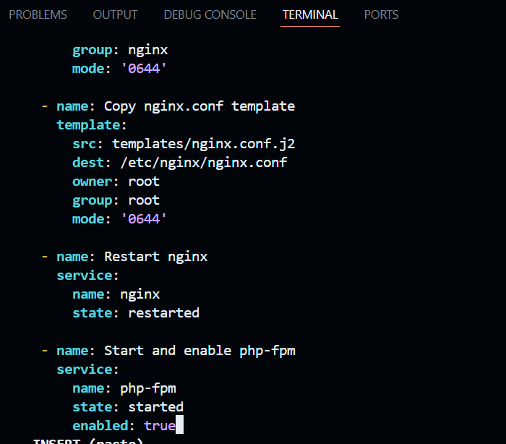

**Run on all instances**: